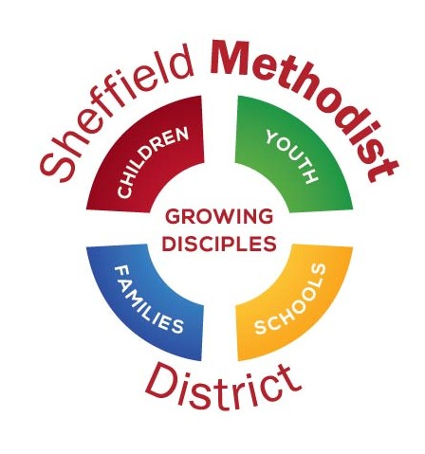
ONE Opportunity Application Form 2024/25
Section 1 : To Be Completed by the Young Person
Part A: Who are you?

Please fill in the following details:

Your Name:
Your Date of Birth:
Your age on 1 September 2024:
Your Home Address:

Email Address:
Telephone No:
Mobile No:

You contact address if different from above:

Will you be in full time education during the academic year Sep 2024/Aug 2025?

What other regular commitments will you have to give time to in this coming year e.g. dance classes, football training, voluntary work, Saturday job?

WORK PERMIT*: Please be aware that under Section 8 of the Asylum and Immigration Act 1996, it is a criminal offence to employ anyone who is not entitled to live or work in the United Kingdom. Applicants will be asked to provide proof of their employable status before we can confirm any offer of appointment e.g. Passport or birth certificate. Are there any restrictions on your right to work in the UK?
YES / NO
If yes, please state restrictions and the expiry date of any permissions.

The amendments to the Rehabilitation of Offenders Act 1974 (Exceptions) Order 1975 (2013 and 2020) provides that when applying for certain jobs and activities, certain convictions and cautions are considered ‘protected’. This means that they do not need to be disclosed to employers, and if they are disclosed, employers cannot take them into account. Guidance about whether a conviction or caution should be disclosed can be found on the Ministry of Justice website. Do you have any Criminal Convictions not “spent” under the Rehabilitation of Offenders Act 1974?
YES / NO
If yes, please supply further details

Part B: Your Parent/Carer Details
If you are still living at home, and particularly if you are under 18, then as part of the process of application, we would like to contact your parents or carers to ensure that everyone is aware of the commitments required by the programme and that they are able to support you effectively. Please provide their names and contact details.

Contact Names:
Address (if different from above):

Telephone Numbers:
Mobile Numbers:
Email Address

Part C: Your Church Connection
In order to fulfil the project, you will need the support, both practically and financially, of your local church. We would like to have a conversation with your minister, and those who have been agreed and identified to support you during the year, should you be successful. We will also be asking your minister to ensure that there is circuit support for you during the year. Please, therefore, give us the following details:-

Your Church Name:
Church Address:

Name of the Minister in Pastoral Charge:

Part D: Tell Us About Yourself

How did you find out about the ONE Opportunity scheme?

Describe your relationship to your church at present:

Have you any previous experience of involvement in church life, particularly in leading, serving, or ministering to others?

Briefly describe your project and what you would hope it will achieve:

What gifts do you have that will enable you to lead this project?

How will you personally benefit from this project?

How do you feel the wider church may benefit?

Are there particular things you will need to be able to make your project happen?

Are you willing to use closed Facebook/WhatsApp groups to communicate with those connected to the programme?
ONE Opportunity Application Form 2024/25
Section 2: Project Details
To be completed by the minister or project enabler, in consultation with the young person.

Part A: Project Details

Name of Project:

Project Website Address (if applicable):

Please take a look at the Application Pack page 8 - Selection Criteria before completing this part of the form.
We would like an overview of the project from you, and this will help us assess which projects/ young people we are able to support this year. The application pack gives an indication of our criteria for the selection process, so reading it will assist you in answering the questions.

Please provide a brief description of the project:

What are the aims and objectives of the project?

Please list the activities that the young person will be involved in:

In what way do you feel this project fulfils the selection criteria?

How would you describe the young person’s faith at present?

What gifts have you identified in the young person?

How will this project benefit the young person?

How do the project hours fit across the year?
e.g. are there activities/events that will require the intern to work over the average 3 hours a week?
are there periods when the intern has exams etc that will require less than the average three hours a week to be worked?
Each intern will be entitled to 20 hours annual leave during their employment which will allow a month’s leave during the year for exam periods or holidays to be accommodated.

What areas of growth or training needs have you identified for the young person at this stage?

Are there any local opportunities, outside this scheme, to enable development in the areas identified above?

How does this project fit into the wider vision of your church or circuit?

Part B: Church/Circuit Support Team
We require that each young person has a local church support team (circuit support team for circuit wide projects), which is made up initially of the minister and project enabler. See the application pack for details of what the role of a project enabler will require.
Once the project has begun a spiritual mentor will be brought into the local church support team, again there are more details about this role in the application pack.
Please provide contact details for the minister and project enabler below.

Minister with Oversight of This Project
Name:
Address:

Telephone No:
Mobile No:
Email Address:

Project Enabler (who will be the primary contact)
Name:
Address:

Telephone No:
Mobile No:
Email Address:

Part C: Approvals Checklist:
Please ensure that all those involved with this project are aware of the responsibilities they are undertaking before sending in this form, including a conversation with the parents/carers for the young person.
 |  | Please tick
Young person
I have read and agree with all the information on this form
I agree to the district co-ordinating team storing my personal data for use in this project only

Signed | ………………………………………………….................... (intern)
Project enabler
I have read and agree with all the information on this form
I am aware of the expectations of the role of project enabler
Signed | …………………………………………………..... (project enabler)
Minister
I have read and agree with all the information on this form
I will encourage and enable the local church support team
Signed | ………………………………………………………………... (minister)
Parents/carers if young person is under 18
I have been informed of the commitments/expectations that my child is undertaking this year:
* working an average of 3 hours a week under the supervision of the local church support team
* attending training days and residential training weekends
* having regular meetings with the local church support team
Signed | …………………………………………………….…... (parent/carer)
We expect that church and circuit support have been acquired, and financial inputs approved. Please could you review the following list, and mark as appropriate.
The following people have been made aware of the project and the financial commitments expected:

Circuit Leadership Team: Project approved YES / NO
Financial contribution amount approved £……… [£500 between sponsoring church and circuit]
Date of meeting approved: ……………………………………………………………………
Contact details of treasurer: ………………………………………………….………………..
………………………………………………………...…………

Church Council: Project approved YES / NO
Financial contribution amount approved £……… [£500 between sponsoring church and circuit]
Date of meeting approved: …………………..………………………………………………
Contact details of treasurer: ……………………………….……………….………………..

