Completing an

Activity Risk Assessment
Part A Only - Introduction

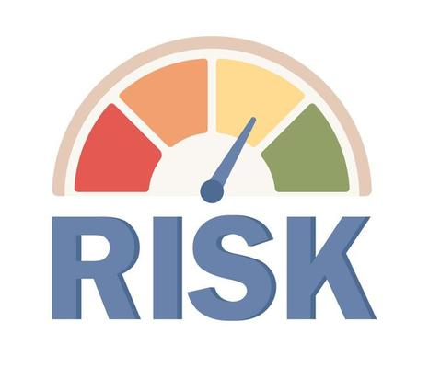

Written by Alison Hill: Regional Safeguarding Officer for the Northeast
Aligned with the Sheffield Methodist District
September 2025

Nature of the Activity
Page 12 Location

Part A

Methodist Context
Safeguarding Policy, Procedures and Guidance for the Methodist Church in Britain – June 2023: page 61
While the Church recognises that it is not possible to avoid all risk when working with vulnerable groups, it is possible to try and minimise those risks. This can be achieved through careful planning and preparation and by providing a written record of the thought processes and action taken. Activity risk assessments should be undertaken before any activity takes place, approved by the event leader/minister and retained securely in case they need to be seen at a later date (e.g. as a result of an accident taking place).
Activity risk assessments should include, but is not limited to:
- the nature of the activity
- the location
- transport needed and associated issues (e.g. insurance)
- staffing levels/gender
- experience of staff
- ages of the group attending, abilities, special needs
- medical and health needs of the group/individuals within it
- emergency planning
- identified risks
- action(s) needed to address the risk and by whom.

Taken from the Model Church Safeguarding Policy – July 2023: page 4
- Good practice
We believe that good practice means:
v) Activity risk assessments will be undertaken before any activity takes place to minimise the risk of harm to those involved. Approval will be obtained from the event leader/minister. A written record of the assessment will be retained securely.

Taken from the Model Circuit Safeguarding Policy – August 2024: page 4
The circuit meeting holds the following responsibilities, which may be delegated to the Circuit Safeguarding Officer, if appropriate:
- Receiving and reviewing church risk assessments and training schedules for each church in the circuit and sharing with the circuit meeting annually.

Introduction for group leaders:

Information for Group Leaders

You should complete an activity risk assessment when starting a new group / activity or moving to a new venue.

It’s important to remember that responsibility for the building’s overall safety lies with the people who manage it—not with you. The church council or property group should be happy to answer any questions you may have.

You should review your activity risk assessment annually and update it as necessary. Consider any risks that might affect volunteers, guests, visitors etc.

The following template (Part B) outlines a wide range of potential risks, designed to cover as many church outreach groups as possible. These include areas addressed in the Safeguarding Policies, Procedures, and Guidance.

Not all listed risks will apply to your group. Please copy and paste the relevant ones to create your own tailored assessment, or mark any that are not applicable as N/A. If you identify a risk not already listed, feel free to add a new line to include it.

All completed activity risk assessments should be submitted to your Church Safeguarding Officer, who will present them to the Church Council as part of their report. Securing the council's approval not only helps share responsibility but also provides you with protection in the event of an incident.

Throughout this document, the term ‘guests’ refers to the group of people your activity is aimed at. For example:
- If you are running a dementia café, the guests are the people with dementia and their carers/family.
- If you are running a Parent and Toddler group, the guests are the children and their parents/carers.

If you have been running the group for a long time and do not plan to complete the full Activity Risk Assessment (Part B), please complete the Activity Checklist (Part D) instead.
While completing the checklist, if you answer ‘no’ to any question, refer to the corresponding question in Part B for guidance on how to manage the risk.

The checklist needs to be signed off by the Minister / Deacon / Lay Pastor and then a copy given to the Church Safeguarding Officer to share with the Church Council.
If you haven’t completed an Activity Risk Assessment before, the following page may be helpful. Writing a thorough assessment ensures that all potential hazards are identified and addressed, helping to protect staff, volunteers, and visitors.

Steps for Writing an Activity Risk Assessment
Step 1: Review the guidelines for setting up a group aimed at vulnerable people:
If you are planning a group aimed at children or young people, read Working with Children and Young People – A Safeguarding Guide for Group Leaders and Volunteers.
If your group includes vulnerable adults, read Working with Adults – A Safeguarding Guide for Group Leaders and Volunteers. (Click here to access the guidance online)

Step 2: Consult with Others
Speak with staff, volunteers, and regular attendees. They may notice hazards you’ve overlooked or recall near-miss incidents that highlight hidden risks.

Step 3: Review Past Incidents
Take time to review previous activities and any problems that occurred. Even minor incidents can provide valuable insights into potential future risks.

Step 4: Consider Special Activities
Think about all the different activities that take place in your group—especially those that involve unique or elevated risks.

Step 5: Decide on Control Measures
Control measures can range from simple fixes, like removing a tripping hazard, to more significant changes. The goal is to eliminate or reduce risks as much as possible.

Step 6: Record Your Findings
Clearly document your findings in the activity risk assessment. Ensure the document is easy to understand and accessible to all staff and volunteers.

Step 7: Implement Control Measures
Put your plan into action. Assign specific tasks and responsibilities, and make sure everyone understands what is expected of them.

Step 8: Monitor and Review Regularly
A risk assessment is not a one-time task. Review it regularly—especially if there are changes to the building, new activities introduced, or following any incidents.

Step 9: Communicate with Everyone Involved
Make sure all leaders and volunteers are aware of the risks and the measures in place. Encourage open communication and feedback to identify and address new hazards promptly.

Step 10: Keep Detailed Records
Maintain comprehensive records. These should include copies of the risk assessment and documentation of any incidents or near-misses. Share a copy of the assessment with your Church Safeguarding Officer, who is responsible for presenting it to the Church Council.

