Understanding Islam: the First Steps.

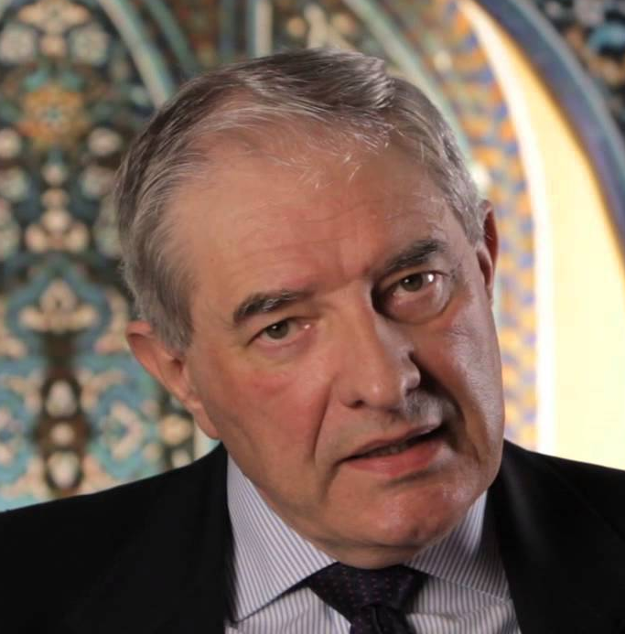
Saturday 22nd November

Led by: Dr Chris Hewer.

This is a day to help us begin to explore what Muslims believe, a journey into understanding Islam from its own perspective.

We will cover the following areas:

- Islam before the time of Muhammad.
- Standing before God.
- Building a Just Society.
- ‘Open House’ – when Chris will respond to your questions.

Venue: St Peter’s, Ellesmere
Lyons Close, Sheffield, S4 7EP

9.30 am arrivals & refreshments. Session 10:00am - 3.30pm

There is no charge, but donations would be welcome on the day. Please bring your own packed lunch.
If you would like to come please contact Rev Liz Wills johnandlizwills@gmail.com or 01142610732

Chris Hewer is a Christian who comes from a background in Christian theology, education, Islamic studies and inter-faith studies. He has worked in the field of Muslims in Britain and Christian-Muslim relations since 1986, including 6 years as Adviser on Inter-Faith Relations to the Bishop of Birmingham. His current work is to teach study days and residential courses, and to develop written and electronic resources.

see more about Chris on: www.chrishewer.org

Everyone is welcome: you don’t need to have any previous knowledge of Islam
and there will be plenty of opportunities to ask questions during the day.

Previous participants comments:

"Best study day I have attended" "I was challenged about my Christian faith"
"Chris Hewer's knowledge is encyclopaedic" "Brilliant, challenging, inspiring”

