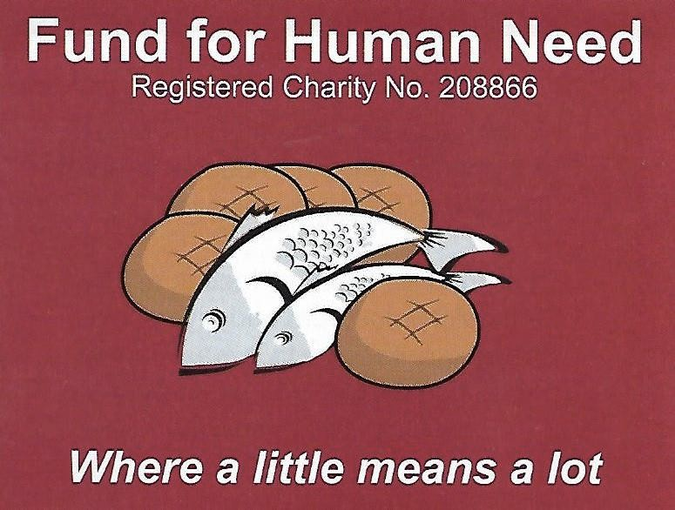

Fund for Human Need

**Report to Autumn Synods 2025**

**Patron: The Rt Hon. the Lord Boateng**

**A delicate balance!**

Income of **£79,430** (to 31 July) in the connexional year just ended has been made up of:

Personal donations £46,190, Church gifts £26,273, Gift Aid £4,447 and other income £2,520

We express our thanks for the generosity shown by all our supporters and, in particular, to the members of Great Ayton Methodist Church who raised a very impressive £8,000 for FHN.

Over the past twelve months 743 grant payments amounting to **£79,431** have been made to people experiencing acute financial difficulty. Eight out of every ten grants have been made through charities, churches and other organisations applying on behalf of individuals or families. Many payments have helped desperate people waiting for a decision on their benefit payments, others to those who find themselves homeless or dealing with mental health or medical issues. We have also seen a significant increase in the number of requests for women who have been subjected to domestic violence.

**Looking to the Future**

For the 65 years of Fund’s existence most of our income has come from Methodist people, for which we are very grateful. Since 2010 our grant payments have totalled more than £750,000. Which has enabled us to respond to about 60% of requests. This year FHN has been accepted as a charity in association with Churches Together in England and it is hoped this will extend our supporter base. In addition, from this September we also expect to benefit from a generous grant to cover administrative costs, which means ***every pound received*** in donations will go to meet genuine human need in all parts of the UK.

**Applying for a Payment**

If you know of someone in need, go to the FHN website for the ‘Applying for a Payment’ form. Please note that priority is given to those who are destitute and where an amount of between £100 and £130 will make a real difference.

**Ways to help**

Are **you** able to consider making a standing order?

Could **your church or circuit** have a special fund-raising event?

Would you sponsor 80-year-old Delia Kennedy in a 100 mile sponsored walk?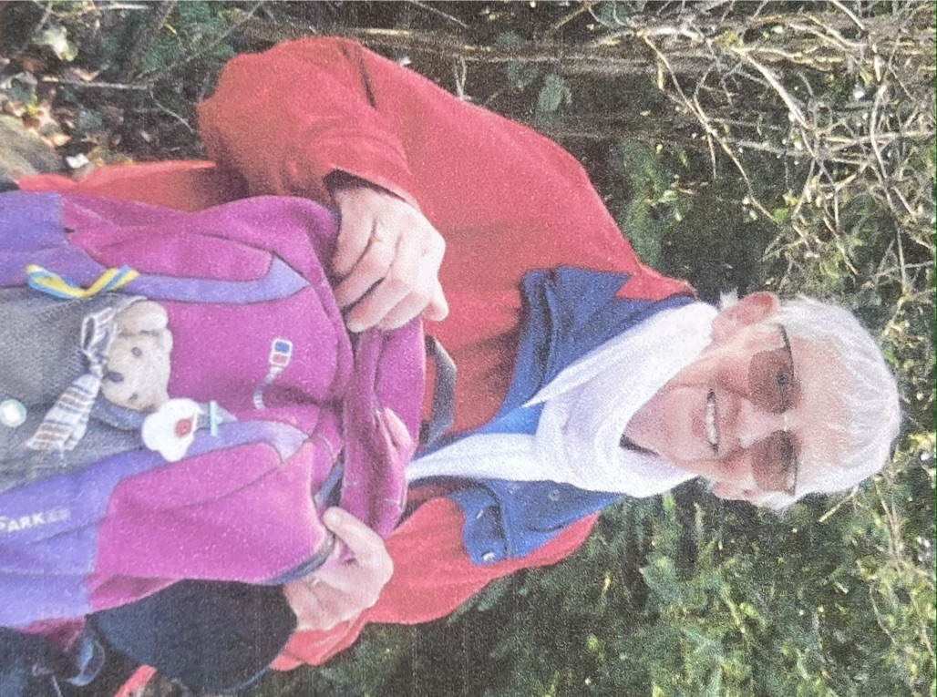

Delia is undertaking this in September to raise funds for FHN and says she sees this as a way of giving thanks for her many blessings. She aims to walk 10 miles on 10 days near her home in Devon - entirely car free. To support Delia please use the JustGiving link on the Fund for Human Need website.

To receive the FHN Newsletter, sent three times a year, with stories of how the emergency payments have helped, contact:

Mrs G. Mason (Administrator), 6 Newlands Road, Darlington, DL3 9JL

Email [fundhumanneed@gmail.com](mailto:fundhumanneed@gmail.com) Phone 07561 717230

website https://fundforhumanneed.org.uk