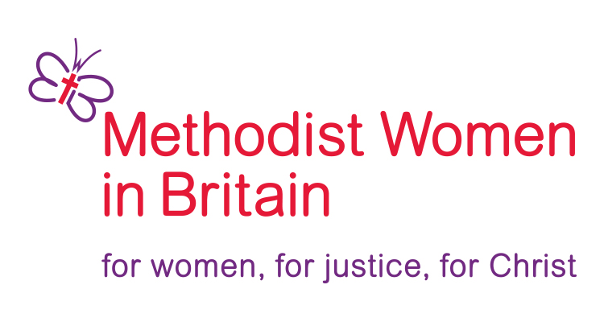

Application to become the
Methodist Women in Britain CoChair
2025–2028

Please complete all parts of the form. The boxes will expand as you type into them.
Sections 1, 2 and 3 to be completed by the applicant.
Sections 4 and 5 to be completed by the referee.

Please return this form, with a photograph, by email to communications.mwib@gmail.com
Applications must be received by April 14th 2025 at 12noon

1) Personal Details

Please insert a recent head-and-shoulders photograph of yourself.
Name
Address

Postcode
Telephone
Email
District

2) Relevant Experience
What experience, skills or knowledge do you have that would enable you to fulfil the role of CoChair? Include any information you consider relevant. This could include paid or voluntary work, general church activities, involvement with issues affecting women, training or education, world church experience, special interests or personal details.

3) Role of MWiB CoChair
What is your vision for women in the Methodist Church and how would you use the role of CoChair to further this vision?

Signed Date

4) Personal details of referee (member of your church, circuit or district)

Name How long have you known the applicant?
Address
In what capacity do you know her?

Postcode
Telephone
Email
District

5) Reference
Please share any insights you think are relevant to the suitability of this person to be the CoChair of Methodist Women in Britain.

Signed Date

