**Lent and Ramadan**

A chance to develop our understanding of fasting amongst our neighbours, who will be keeping the month of Ramadan from 10th March onwards

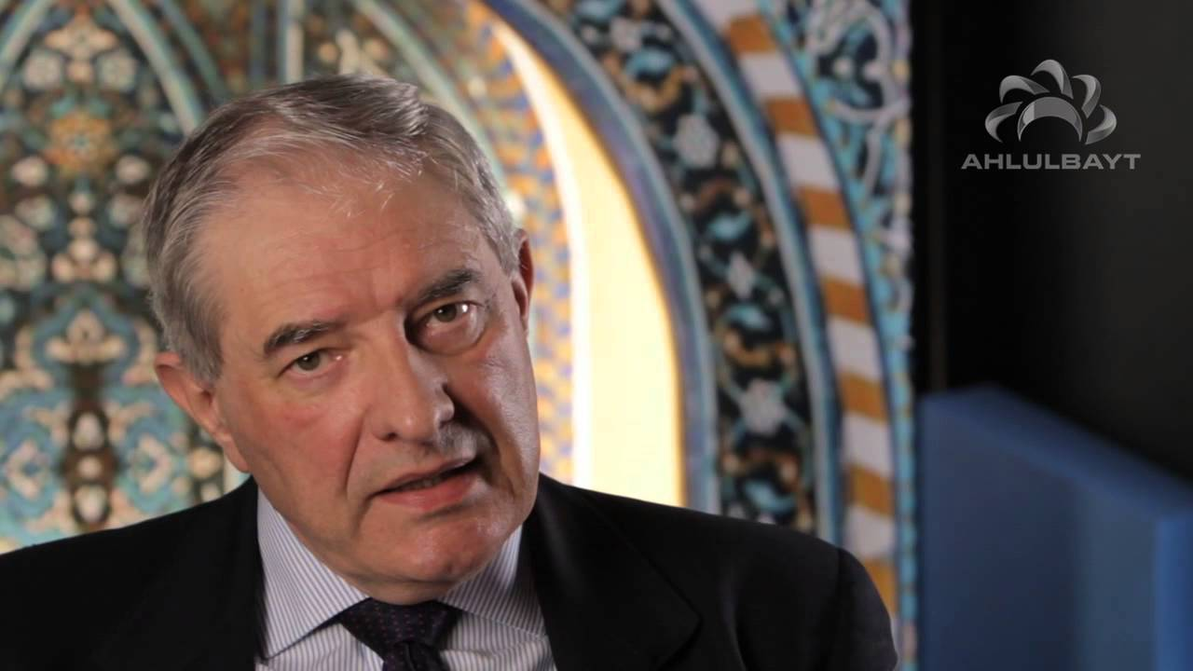

**Led by:Dr Chris Hewer**

***Saturday March 23rd:***

***10.30 – 12.30***

***With teas/coffees from 10.00 a.m.***

**Venue: The Welcome Centre**

**Christ Church Pitsmoor, Pitsmoor Rd,**

**Sheffield S3 9AQ**

*Everyone Welcome*

**Chris Hewer** is a Christian who comes from a background in Christian theology, education, Islamic studies and inter-faith studies. He has worked in the field of Muslims in Britain and Christian-Muslim relations since 1986, including 6 years as Adviser on Inter-Faith Relations to the Bishop of Birmingham. His current work is to teach study days and residential courses, and to develop written and electronic resources. His book ‘*A Short Guide to Understanding Islam*’ has been published by a London mosque to be given to non-Muslims wanting to learn about Islam.

**see more about Chris on:** [**www.chrishewer.org**](http://www.chrishewer.org)