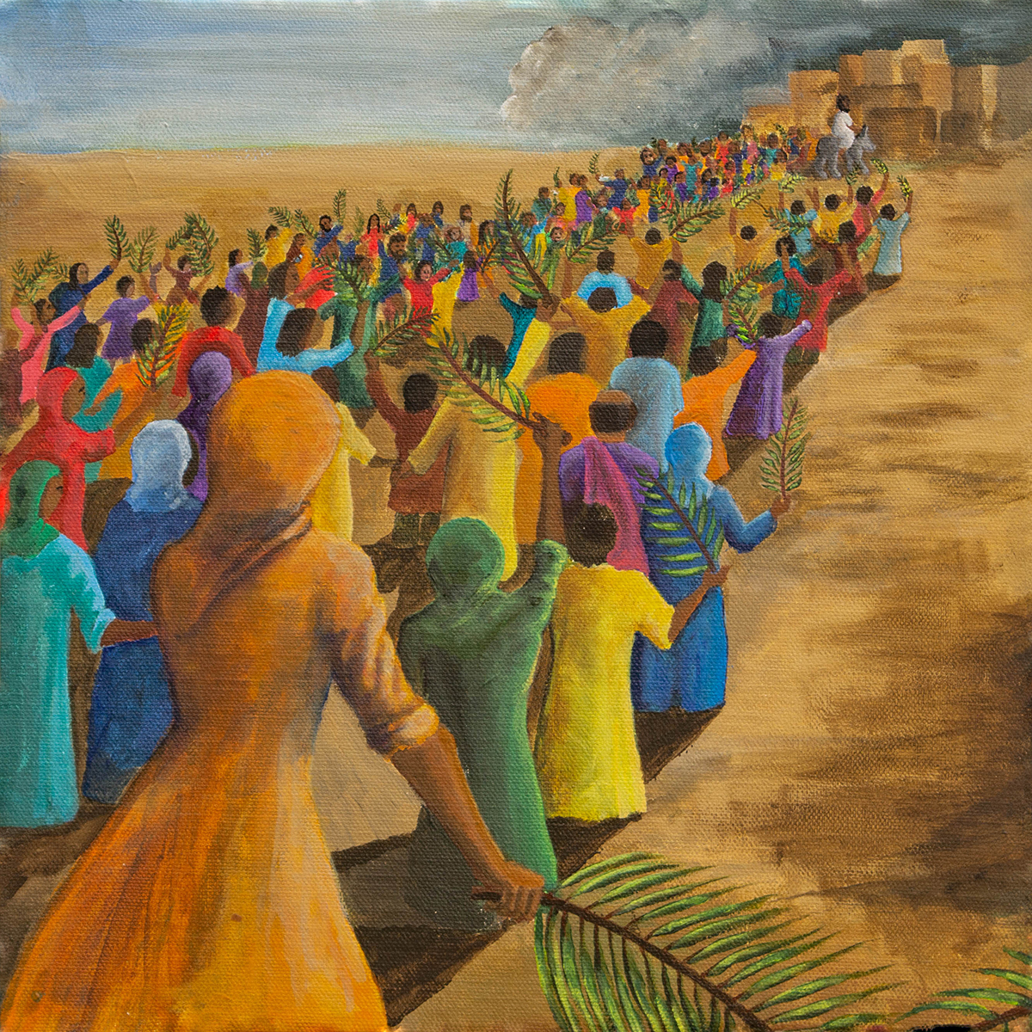
Monyash Holy Week Wander and Wonder Event
Ever about the women of Holy Week?

In the book Women of Holy Week, Paula Gooder presents nine different but interlinked women. Artist Ally Barrett interprets these stories through her paintings and together they bring a new dimension to our reflections in Holy Week.

© Ally Barrett (www.reverendally.org) and used by permission.

You are warmly invited to join us in Monyash to Wonder and Wander through the paintings of Ally Barrett on the Women of Holy Week

On: Thursday 6th April 10:30 - 16:30
Friday 7th April 10:30 - 14:00
Saturday 8th April 10:30 - 16:30
Sunday 9th April 12:30 - 17:30 followed by
Sunday Easter reflections 18:00 – 18:45

AT: Monyash Methodist Church, Chapel Street, Monyash DE45 1HE

Reflecting on the Women of Holy Week in Lent
Deacon Lorraine would be delighted if you were interested in joining her in Monyash, on a Tuesday evening through Holy Week 7:30pm – 8:30pm to reflect on The Women of Holy Week by Paula Gooder.
Please contact Lorraine on peakpark@sheffieldmethodist.org or Mob: 07483 814111

