

**CREATING SAFER SPACE**

Foundation Module   
2020 Edition (Modified 2022)



**Trainers’ Notes**

**Online & Face-to-face**

# CREATING SAFER SPACE

# Foundation Module Training Notes

These Foundation Module training notes are in 3 parts, to enable trainers to lead either face-to-face or online sessions. There are obviously many aspects of the training, which are common to both methods of delivery **(Part A)**, whilst there are significant differences in the practicalities of preparing for face-to-face training **(Part B)** and delivering online training **(Part C).**

**Contents**

|  |  |
| --- | --- |
| **Part A – all forms of training**  Who delivers the training………………………………………………………..  Learning Activities………………………………………………………………..  Reflection on, and planning for, resistance……………………………….......  **Part B – face-to-face training**  Getting started……………………………………………………………………  Materials and equipment………………………………………………………..  On the day…………………………………………………………………...…...  Question Park………………………………………………………………........  Workbook………………………………………………………………………....  Handbook………………………………………………………………………....  Signing-in sheet………………………………………………………………….  **Part C – online training**  Getting ready for the Zoom training session………………………………….  Booking for the training……………………………………………………….....  Pre-course email…………………………..……………………………………..  Materials and equipment………………………………………………………..  On the day………………………………………………………………………..  Question Park – via the Chat Function…………………………………..……  Handbook and Workbook……………………………………………………….  Signing-in sheet………………………………………………………………….  **Timings** ……………………………………………………………….………………..  **Section 1** - Welcome and devotions (slides 1-6, 17 minutes) ……………………..  **Section 2** - Our Church Context (slides 7-23, 34 minutes)…………………………  **Section 3** - Good Practice (Slides 24 – 26, 33 minutes) ……………………………  **Section 4** - Four Steps to Good Practice (slides 28–35; 39 minutes)……………..  **Section 5** - Case Studies (slide 36, 20 minutes)……………………………………..  **Section 6** - Reflection, evaluation and close (Slides 37-44, 13 minutes)………….  **Appendix I** – Case studies preparation …………………………………………….. | A  3  3  3  6  6  6  7  7  7  7  9  10  10  10  11  11  11  11  13  16  20  30  34  42  43  50 |

**Part A – all forms of training**

**Who delivers the training?**

It is recommended that two trainers deliver the Foundation Module and, wherever possible, it is advisable to have a named chaplain. The trainers must have been trained locally to present this module of Safeguarding Training, in the mode which they are delivering. **The Foundation Module should never be delivered alone.**

**Learning activities**

All the learning activities must be included as they are designed to:

● support a range of learning styles

● develop a deeper understanding of safeguarding issues

● enable the application of models, theories and concepts

● extend knowledge

● promote reflection.

### **Reflection on, and planning for, resistance**

We are aware that sometimes trainers have encountered resistance from within groups undertaking safeguarding training and we thought it might be helpful to share some thinking on this as preparation for the training.

Resistance in training usually stems from the need of the participant to either:

* exert their strength and control
* or defend their weakness.

In safeguarding training, the reasons may be more complex as the material can be difficult and distressing and the individual may be struggling to deal with discomfort and pain.

However, a few resistant people can really get in the way of others benefitting from the learning experience.

Resistance in training can be very off-putting and difficult for trainers and for other participants. We hope, therefore, that these guidelines will be useful in supporting you to constructively prepare for, and then handle, any resistance.

**Forms of resistance and possible ways of dealing with it**

* **Questions that are not directly related to the topic (e.g. does a particular role need an enhanced disclosure check?):** Use the Question Park

* **Taking issue with the detail of a case study:** Keep the focus on the learning objectives of the case study rather than getting into debates about the detail.
* **Questions that are controversial – not directly related to the topic but engender a lot of interest:** Confidently and clearly explain that while this is very interesting there will not be time to discuss this as well as covering the material and that you need to keep a focus on the material.
* **Competition with you for authority:** Try not to get into the dynamic of competition. Aim to value and use the knowledge of the person without alienating the rest of the group.
* **Asking difficult questions to which you don’t know the answer:** Don’t pretend to know what you don’t. Use the Question Park. Politely explain that you will check it out.
* **Avoiding the task associated with the case study/activity:** Take the opportunity to reflect on why this may be happening without blaming an individual.
* **Noting gaps/contradictions in Methodist Church Policy:** Don’t get sucked in – agree to make a note and feedback to Methodist Church Safeguarding.
* **Direct challenges to you as the trainer:** Try not to get into a one-to-one confrontation with any one participant. Try not to take it personally. Aim to divert the challenge and defuse the situation. It may be useful to take a five-minute break or use the co-trainer to take the individual out for a one-to-one conversation.
* **Not participating in learning activities:** If there is a pattern of this you may need to take the person on one side and ask if there is a reason for this.
* **Questioning the legal context for safeguarding:** The Safeguarding Policy, Procedures and Guidance for the Methodist Church outlines the legal framework and context for safeguarding, so signpost them to the online document to answer their questions.

**Awareness of resistance**

You may suspect resistance because of a ‘gut’ feeling arising from noticing a reluctance to engage, a sense of resentment, difficult communication or avoidance.

Here is a way of checking this out:

* The first time something difficult occurs accept it in good faith.
* The second time: accept in good faith but note it privately and discuss with your co-trainer if possible.
* The third time: deal with it with the individual.

Dealing with the individual may need to be outside the group during a coffee break. Or if there are two trainers one might be able to ask the individual to leave a small group activity for a quick chat.

It can be helpful to:

* name the resistance – point out what seems to be happening in a neutral way without attributing blame or judgement
* remain silent in order to elicit a response
* once the person has responded the trainer and the person can work on whatever the issue is
* if the person denies resistance avoid justifications and move on – noting the response should this be needed in the future.

Other issues to consider:

* It is not helpful to view resistance as a personal attack.
* It might be helpful to refer back to the learning agreement.
* Remember the resistance is due to an underlying problem and you are experiencing the manifestation of this. You may not be able to resolve the problem, but you may be able to improve the experience for the rest of the group.
* Keep a clear focus on the learning aims and objectives for the whole group.
* Be available for the individual separately should they wish to share with you their difficulty with taking part in the training.

**Tips for maintaining appropriate boundaries**

These tips may be especially helpful when looking at those who have experienced abuse (slides 16-17), people who may be a risk to others (slides 18-19) and different types of abuse (slides 28-29).

* Stay Professional – this is not the time to share personal stories or allow emotion to cloud your training skills.
* Respect – hold in mind a person or people whom you know. Would you think it appropriate for their story to be shared in this way or related in their presence? If not, then don’t say it.
* Share on a need-to-know- basis – any group of people at any training need to know a certain amount of information. They never need to know everything you know! So as you plan and speak, edit – rigorously, professionally and respectfully.
* Keep sexual abuse in context – be proportionate as far as possible.

**Part B – face to face training**

## Getting ready for the training session

### **Materials and equipment**

The materials you will need to deliver the session include:

* Creating Safer Spaces: Foundation PowerPoint presentation
* Copies of the Foundation Module Workbook, enough for each participant
* Copies of the Foundation Module Handbook, enough for each participant
* Copies of *Safeguarding: A quick reference guide for those working with the Methodist Church*, enough for each participant
* Copies of the evaluation form*, enough for each participant
* Signing in sheet*
* Copies of the Safeguarding Training Privacy Notice*
* A printout of the bible verse used in the Devotions

Trainers will require the following equipment to deliver the session:

* laptop, speaker and projection facilities (may need an extension lead)
* flip chart paper, stand and pens.
* post-it notes
* question park*
* welcome signs*
* refreshments – tea / coffee etc. depending on local arrangements

* Available to download and print from the Foundation Module Trainers section of the Methodist Church website.

In light of the materials required to deliver this training, trainers will need to ensure that all necessary equipment will be available on the day: projector, laptop, flipchart paper and stand. It can be helpful to have some spare pens available so participants can take notes and for completion of the Workbook and feedback forms.

### 

### **On the day**

Both trainers should arrive early and check all the equipment. Here is a checklist to follow:

* Set up the room with a flip chart stand and have paper, pens (use black or blue for visibility) and post-it notes on each table. Some trainers use a resources table, empty at the start but gradually built up with the resources as they are used through the training.
* Create a welcoming atmosphere. Try to have seats round tables, café style – avoid straight rows if at all possible. Have refreshments ready for when people arrive. Maybe have flowers on the tables and music playing. Have sweets and water on tables as well as hot drinks available wherever appropriate for the venue.
* If the venue has the facilities you could set up a quiet room so that those who need to go out have a comfortable, safe space to use.
* Ensure there is someone on the door to welcome people personally as they arrive and ensure they sign in. They may need to stay there after you have started to ensure that latecomers are welcomed, sign in and are integrated into the group.

Timings are indicative to help you plan the session. It is helpful for the group to have an indication of the programme for the day and the sections which will be covered with approximate timings. This can be written on a flip chart.

### **Question Park**

This is a useful tool to help you keep the session moving and to hold in mind questions that will be covered later, hold questions you need to find out more information for and to prevent the group becoming ‘stuck’ on a single issue. For this to work well, have a big piece of flipchart paper on the wall titled Question Park, and make sure that each small table has plenty of post-it notes available, so they can record questions as they go.

It is important that you follow up on any unanswered questions and get back to the group with the answers, even if it is a little while after the session has taken place.

### **Workbook**

The Workbook contains all the handouts for the session, including the case studies and the Learning Log (see page 18 for more information about the Learning Log). Participants should write their names on the front, along with their role(s) within the life of the church.

### **Handbook**

The Handbook contains additional information that builds on material covered during the Foundation Module 2020 training course. It also provides participants with some suggested resources for further learning and development, and signposts to some potentially helpful organisations.

### **Signing-in Sheet**

The signing-in sheet must be used with the Safeguarding Training Privacy Notice. This is because, unlike most training sessions where the data collected is simply used on the day (for fire regulations, certificates etc), the Methodist Church will be keeping the information on who attends.

The personal data will then be used to keep a record of when individuals are next required to complete another safeguarding training course, and at what level (Foundation Module or Advanced Module) depending on their role(s). To comply with GDPR (General Data Protection Regulation) the Methodist Church must inform participants of their rights and provide information about how the personal data is held and used.

You may wish to email participants the Safeguarding Training Privacy Notice before the session (along with the aims of the course and any confirmation details) or to have some copies printed off and to hand on the day.

**Part C – online training**

## Getting ready for the Zoom training session

Ideally, there should be a training team of four people involved in the delivery of the on-line training.

**Trainers x 2**

* To deliver the course material in accordance with the trainer’s notes
* To screenshare and control the PowerPoint presentation and whiteboard
* To have a debrief session after the course to review feedback etc.

**Chaplain/ Minister**

* It is suggested that your chaplain is introduced to the group and leads the devotions – as they would in a face to face session – therefore, participants are aware that they are there and can contact them if needed
* To be present throughout the duration of the online session
* To keep a watchful eye on all participants and to notice if anyone is struggling
* If so, to phone them to see if they can help
* To receive phone calls from participants during or after the session if they need to talk
* To respond to ‘chat’ messages requesting pastoral help
* You may wish to consider having a designated time directly after the training ends, to enable anyone with pastoral concerns to speak further to the chaplain or trainers
* Ensure that there is clarity for your participants regarding who they can contact for additional pastoral support following the training day

**‘Zoom’ Co-ordinator**

*(The allocation of these tasks will vary from District to District, but all actions need to be covered by someone)*

* To schedule the meeting and provide the link to all participants along with the PDF file of the Handbook and Workbook and any other papers required
* To admit people to the room as they arrive
* To set the chat function to ‘with hosts only’
* To ‘mute’ and ‘unmute’ people when they need to participate
* To allocate breakout groups and send people to rooms at the appropriate time
* To bring people back from breakout rooms at the appropriate time
* To monitor the ‘chat’ facility, collate questions and pass them on to the trainers
* To watch for people’s link dropping out and to re-admit them
* To endeavour to solve any technical hitches that arise

It may not be achievable to have four people and the above roles may have to be redistributed amongst those available. However, **the Foundation Module should never be delivered alone.**

**Booking for the training**

It is recommended that the number of participants per session is capped at 20. This means that when using gallery view on Zoom everyone participating in the session will be visible.

People wanting to book on to a session should be asked to provide:

* Name
* Email address [needed to send the training details to]
* Contact phone number – preferably a mobile number [needed in case the Chaplain needs to call them during the training, or there are technical difficulties]
* Role
* Church
* Circuit

**Pre-course email**

Prior to the course an email needs to be sent to each participant which includes the following information

* Log in details for the Zoom training
* Chaplain’s contact phone number

The email will also need to have the following added as attachments:

* Handbook [PDF file] – page 6 outlines the aims of the training
* Workbook [PDF file]
* Privacy Notice [PDF file]

### **Materials and equipment**

The materials you will need to deliver the session include:

* Creating Safer Space: Foundation Module (Modified 2022) PowerPoint presentation
* Foundation Module (2020) Handbook
* Foundation Module (2020 Edition, modified 2022) Workbook
* Signing in sheet
* Breakout Room Allocation sheet
* An electronic certificate of attendance for each participant

Trainers will require the following equipment and facilities to deliver the session:

* Laptop with ‘Zoom’ downloaded
* ‘Zoom’ licence
* Ensure that your laptop has webcam and audio facilities; you may wish to invest in a microphone headset to ensure clear audio
* Knowledge of how to ‘screen share’ in Zoom
* Familiarisation with how Zoom displays on the device you are using – you may like to set up a practice session with your team, so you can take a look at the layout and how you can best organise your screen

### **On the day**

The training team should log on early, check that all the Zoom functions are working and enable joint ‘hosts’.

As participants arrive the Zoom co-ordinator will admit them while the trainers and chaplain create a welcoming atmosphere and engage in general conversation with the participants until the starting time.

Timings are indicative to help you plan the session. It is helpful for the group to have an indication of the programme for the day and the sections that will be covered with approximate timings. You can write these on the ‘chat’.

### **Question Park – via Chat Function**

This is a useful tool to help you keep the session moving. If someone has a question about an issue that will be covered later or can’t be answered immediately, they can write it on the Chat. This prevents the group becoming ‘stuck’ on a single issue.

Tell the group that you will follow up on any unanswered questions and get back with the answers, although it might be a little while after the session has taken place.

### **Handbook and Workbook**

The Handbook contains additional information that builds on material covered during the Foundation Module 2020 training course. It also provides participants with some suggested resources for further learning and development, and signposts to some potentially helpful organisations.

The Workbook contains all the handouts for the session, including the case studies and the Learning Log. Participants should write their names on the front, along with their role(s) within the church.

Ideally, participants should have a hard copy of the handbook and workbook ahead of the session. Trainers need to work out the best way for this to happen. You may need to consider asking participants to collect these from a pre-determined location, or delivering them to the participant’s address, or posting them.

An electronic copy of the Handbook and workbook is downloadable from the training pages at: <https://www.methodist.org.uk/safeguarding/training/>

### **Signing-in sheet**

A ‘signing-in’ sheet should be completed by the Zoom co-ordinator as people arrive, and the details of who attended should be passed on to the Circuit and/or District Safeguarding Officers after the course, in accordance with local processes.

The signing-in sheet must be used with the Safeguarding Training Privacy Notice. This is because, unlike most training sessions where the data collected is simply used on the day (for fire regulations, certificates etc), the Methodist Church will be keeping the information regarding who attends. The personal data will then be used to keep a record of when individuals are next required to complete another safeguarding training course, and at what level (Foundation Module or Advanced Module) depending on their role(s).

To comply with GDPR (General Data Protection Regulation) the Methodist Church must inform participants of their rights and provide information about how their personal data is held and used. The Safeguarding Training Privacy Notice should be emailed to participants in the pre-course email (see above).

|  |  |  |  |  |  |  |  |
| --- | --- | --- | --- | --- | --- | --- | --- |
| **Number**  **Timings - example** | **Slide** | **Trainer 1** | **Trainer 2** | **Activity** | **Duration** | **Timings (example)** | |
|  | | | | |  | **10.00 start** | **19.00 start** |
| **Section 1: Welcome and devotions (slides 1- 6, 17 mins)** | | | | | | | |
| **1** | **Welcome** | **Lead** |  |  | 1 min | **10.01** | **19.01** |
| **2** | **Devotions** |  | **Lead or pastoral support** |  | 4 min | **10.05** | **19.05** |
| **3** | **Setting the scene** | **Lead** |  |  | 4 min | **10.09** | **19.09** |
| **4** | **Course Overview** | **Lead** |  |  | 1 min | **10.10** | **19.10** |
| **5** | **Session Agreement** | **Lead** |  |  | 1 min | **10.11** | **19.11** |
| **6** | **Introductions** | **Lead** |  | **5 min in group**  **1 min feed back** | 6 min | **10.17** | **19.17** |
| **Section 2: Our Church Context (slides 7-23) 34 min** | | | | | | | |
| **7** | **What makes the Church unique?** |  | **Lead** |  | 2 min | **10.19** | **19.19** |
| **8** | **Children and young people** | **Lead** |  |  | 1 min | **10.20** | **19.20** |
| **9** | **Good practice** | **Lead** |  |  | 2 min | **10.22** | **19.22** |
| **10** | **Vulnerable adults** |  | **Lead** |  | 1 min | **10.23** | **19.23** |
| **11** | **What can make an adult vulnerable?** |  | **Lead** | **5 min in group**  **1 min feed back** | 6 min | **10.29** | **19.29** |
| **12 OR** | **Recognising abuse** |  | **Lead** | **5 min in group**  **2 min feed back** | 7 min | **10.36** | **19.36** |
| **13** | **Enfield video** |  | **Lead** | **Video – 7 min 20 secs (8 min)**  **2 min activity** | 10 min | **10.46** | **19.46** |
| **14** | **Good practice** |  | **Lead** |  | 1 min | **10.47** | **19.47** |
| **15** | **Those who have experienced abuse** | **Lead** |  |  | 1 min | **10.48** | **19.48** |
| **16** | **Good practice** | **Lead** |  |  | 1 min | **10.49** | **19.49** |
| **17** | **Those who may be a risk to others** |  | **Lead** |  | 1 min | **10.50** | **19.50** |
| **18** | **Good practice** |  | **Lead** |  | 1 min | **10.51** | **19.51** |
| **19** | **Church leaders, staff and volunteers** | **Lead** |  |  | 1 min | **10.52** | **19.52** |
| **20** | **Church leaders, staff and volunteers (2)** | **Lead** |  |  | 1 min | **10.53** | **19.53** |
| **21** | **Keeping yourself safe** | **Lead** |  |  | 2 min | **10.55** | **19.55** |
| **22** | **Good practice** | **Lead** |  |  | 2 min | **10.57** | **19.57** |
| **23** | **We welcome all safely** |  | **Lead** |  | 2 min | **10.59** | **19.59** |
| **Section 3: Good Practice (Slides 24-26, 33min)** | | | | | | | |
| **24** | **4Ps** |  | **Lead** |  | 2 min | **11.01** | **20.01** |
| **25** | **‘Somewhere’ Methodist Church** | **Introduce**  **Facilitate feedback after each paragraph** | **Read Somewhere**  **MC** | **4 min**  **4 min** | 8 min | **11.09** | **20.09** |
| **26** | **Your context** |  | **Lead** | **5 min in group**  **2 min feed back** | 7 min | **11.16** | **20.16** |
| **27** | **Comfort break** |  |  |  | 10  min | **11.26** | **20.26** |

|  |  |  |  |  |  |  |  |
| --- | --- | --- | --- | --- | --- | --- | --- |
| **Section 4: Four steps to good practice (slides 28-31) 39 min** | | | | | | | |
| **28** | **Four steps to good practice** | **Lead** |  |  | 1 min | **11.27** | **20.27** |
| **29** | **Recognising Abuse** | **Lead** |  | **10 min in group**  **1 min feed back** | 11 min | **11.38** | **20.38** |
| **30** | **Recognise, be curious** |  | **Lead** |  | 1 min | **11.39** | **20.39** |
| **31** | **Recognising barriers to disclosing abuse** | **Lead** |  | **Shout out activity** | 5 min | **11.44** | **20.44** |
| **32** | **Respond: what to do** |  | **Lead** |  | 2 min | **11.46** | **20.46** |
| **33** | **Respond: what stops us doing it well** | **Lead** |  | **8 min in group**  **4 min feed back** | 12 min | **11.58** | **20.58** |
| **34** | **Record** |  | **Lead** | **Video 3 min 7 sec** | 4 min | **12.02** | **21.02** |
| **35** | **Refer/report** | **Lead** |  |  | 1 min | **12.03** | **21.03** |
| **Section 5: Case Studies (slide 35) 20 min** | | | | | | | |
| **36** | **Case Studies** |  | **Lead** | **10 min group**  **10 min feed back** | 20 min | **12.23** | **21. 23** |
| **Section 6: Reflection, Evaluation and Close (slides 36 - 41) 13 min** | | | | | | | |
| **37** | **Awareness test** | **Lead** |  | **Video 1 min 27 sec** | 3 min | **12.26** | **21.26** |
| **38** | **Review** |  | **Lead** |  | 1 min | **12.27** | **21.27** |
| **39** | **Where do I fit in?** |  | **Lead** | **Video 15 secs** | 1 min | **12.28** | **21.28** |
| **39** | **Question park** |  |  |  | 2 min | **12.30** | **21.30** |
| **40** | **Learning log** |  |  |  | 1 min | **12.31** | **21.31** |
| **40** | **Feed back** |  |  |  | 1 min | **12.32** | **21.32** |
| **41** | **Closing Devotions** | **Lead or pastoral support** |  |  | 3 min | **12.35** | **21.35** |
| **42** | **Thank you** |  |  |  | 1 min | **12.36** | **21.36** |

**Section 1: Welcome and devotions (slides 1- 7, 17 mins)**

|  |
| --- |
| *P****lease note***that throughout these notesplain text can be used as a script*, text in italics is for instructions or additional information.* |

**Slide 1: Welcome 1 min**

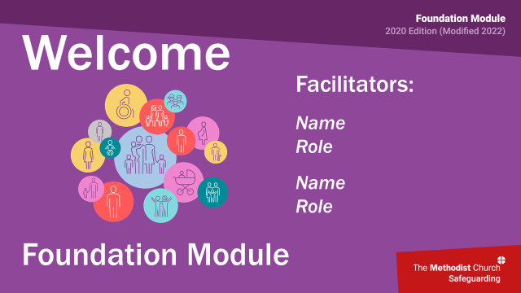 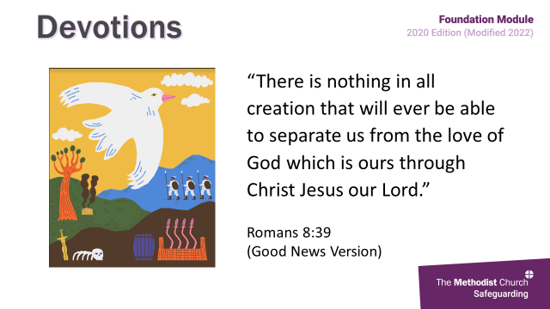

**Face to face** **Online**

*Zoom coordinator lets everyone in gradually, ensuring that they have their name up in full and verifying roles within the church if this is not clear at booking.*

*Trainers, and chaplain (if available) introduce themselves*

*If no chaplain is available explain how pastoral support will be provided.*

*Display this slide in the background as the group arrive and settle ready for the course to start*

*Trainers, and chaplain (if available) introduce themselves*

*If no chaplain is available explain how pastoral support will be provided.*

**Slide 2: Devotions 4 mins**

 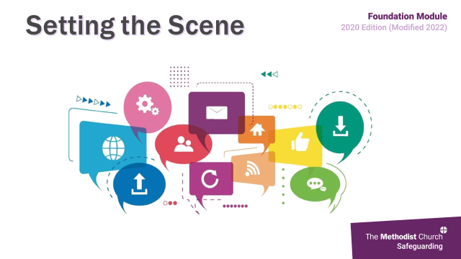

“There is nothing in all creation that will ever be able to separate us from the love of God which is ours through Christ Jesus our Lord.” Romans 8:39 (Good News Version)

In Romans 8, Paul sets out the wonderful declaration that nothing can separate us from the love of God. This does not mean that God offers us cheap love, nor does it set aside the requirement for us to respond with love, justice and mercy. Elsewhere, Paul is very clear about what God yearns to see in response from each individual. For people who face difficulties and for whom this world can feel a very unloving, scary place, this passage can be hugely reassuring.

Loving God, help us to remember that all people are made in your image and are worthy of care, love and respect.

When we have ignored the needs of the most vulnerable people, forgive us.

When we have believed the powerful and disregarded the cries of the voiceless, forgive us.

Help us to transform our church into a place of safety

Where we can tell our stories,

Where we can choose to show the scars of wounded bodies, hearts and minds, Where there is the possibility of healing and a willingness to stand as pain bearers for one another God who bears all things, help us.

And bless the people. Amen.

*Originally from the Survivor’s Prayer Card*

**Slide 3: Setting the scene 4 mins**

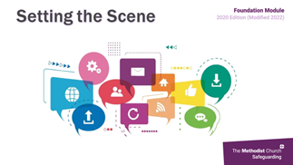 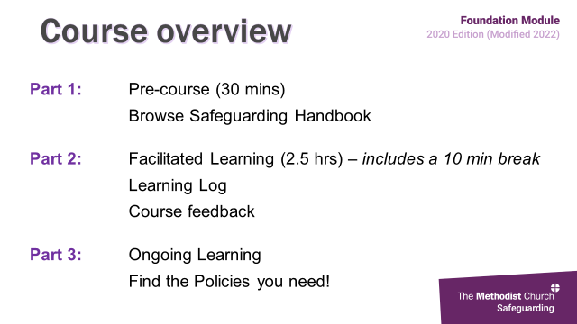

This is an interactive session, and we will use a range of media to aid your learning. However, we all bring with us a range of experience and it is this sharing and your discussions which will really enhance your learning.

But we mustn’t forget that there may be those among us who have personal experience and so we need to approach this very challenging area with sensitivity, respect and consideration and it is important at this point to reiterate the pastoral support available to you both during and after the session.

*Offer brief introduction to:*

*Housekeeping arrangements: mobile phone, toilets, fire exits*

* *Workbooks, handbooks and safeguarding card*
* *Learning log*
* *Question park*
* *Signing in sheet*
* *Spokesperson for feed back*

*Zoom: use screenshare for slides and videos, breakout room, chat and reactions*

* *Workbooks, handbooks – will have been emailed*
* *Safeguarding card – how to get one*
* *Learning log*
* *Questions into chat*
* *Spokesperson for feed back*

**Slide 4: Course overview 1 min**

 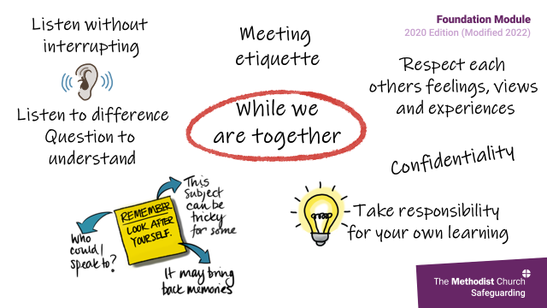

This session is only a part of the Foundation Module. It is also about the pre-reading you undertook and your ongoing learning.

Within this session we will look at safeguarding in the church context, good practice and the steps we need to take within our roles before then putting some of this into practice when we look at a number of case studies.

Using your learning log, which can also be found on page 13 of your Workbook, will enable you to record what you have learned, consider how this may impact on your own role/s within the Church and identify any conversations or actions you may need to make when you return to your churches.

From today onwards, use your handbook as a reference and ensure you know where to find policies on the Connexional website.

We will endeavour to keep to time and ensure that you have a brief 10-minute comfort break.

Please remember that some of the content and discussions within the session can be difficult for any of us at any time. If you need a break,

Feel free to leave the room for a few moments, but please don’t leave the building.

If you would like pastoral support, please just indicate this.

Feel free to turn off the video and audio functions for a little while.

If you feel you need to speak with someone, please let the person offering pastoral support today know, by telephone/through chat.

Feelings can hit us at any time, even after the session, so if they do, please share them with someone you trust. Above all, look after yourself.

**Slide 5: Session agreement 1 min**

 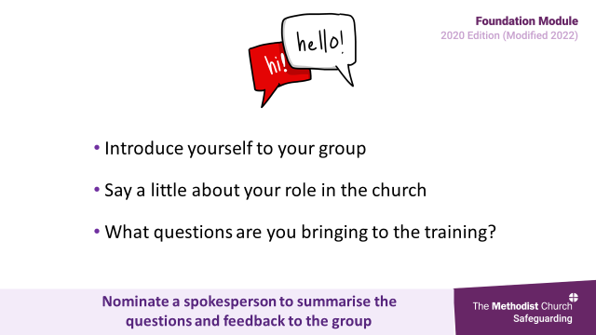

This slide represents our agreement to one another within this session – in brief, to respect one others’ views and opinions and issues of confidentiality and that we will look after ourselves and one another.

**Slide 6: Participant introductions 6 mins**

 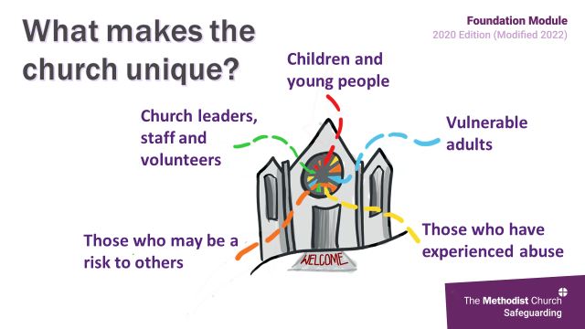

*Depending on the number in the session you may choose to share introductions together. Alternatively, participants may be put into small groups of 4-6, either physically or in breakout rooms for 5 mins.*

*Ask participants to introduce themselves: where they’re from, roles within the Church, questions they are bringing and one thing they hope to take from todays sesssion – jot this down and hold onto it until the end. If covered within smaller groups ask for a spokesperson to give a brief summary.*

**Section 2: Our Church Context (slides 7-23) *34 mins***

**Slide 7: What makes the church unique?** **2 mins**

 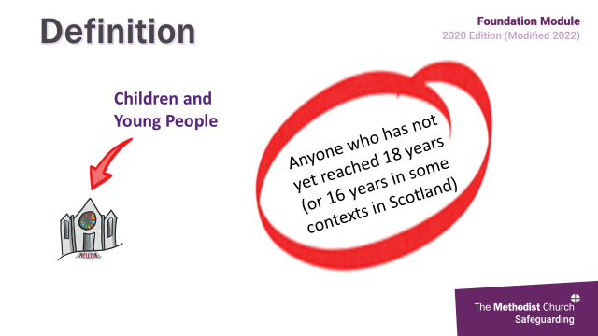

*(N.B. The PowerPoint slides play automatically)*

Some of you may have experience of safeguarding and training in other walks of life and professions. That training will be valuable today and many of the fundamentals are likely to be similar. However, this training is different because it focusses on those unique challenges of safeguarding in the context of the Church and creating a safe space for all within our church communities where those who are vulnerable are respected, valued, protected and listened to. This is at the core of our faith.

Within our church communities, five different groups of people all share a rightful place. These groups are:

* children and young people
* adults who may be vulnerable
* those who have experienced abuse
* those who may be a risk to others because that have previously perpetrated abuse or because they have the potential to abuse
* church leaders, staff and volunteers.

For those who have attended any previous versions of the Foundation Module, you will see that this a new category, introduced because it recognises that we need to look after the people who fulfil these roles and to keep them safe also.

In the next few slides, we will look at how we can manage the challenge of balancing the needs of each of these groups, and this balancing act takes constant awareness, sensitivity, prayerfulness and communication, as well as adhering to safeguarding policies and being vigilant for risks. This information can be found from p 7-14 in your Handbook.

**Slide 8: Definition of children and young people 1 min**

 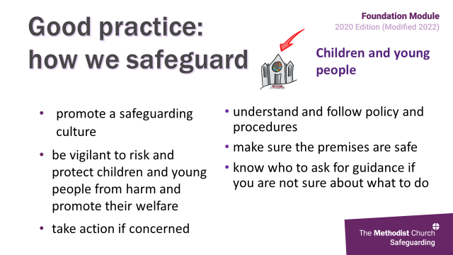

In England, a child is defined as being anyone who hasn’t reached their 18th birthday and in Scotland it’s their 16th. Children are inherently vulnerable due to their age, degree of development and emotional maturity, and dependence upon adults to take care of them. Their age and level of maturity may mean that they have no control over what happens to them. However, they may also have other vulnerabilities too, such as being disabled, being a young carer, or not having English as their first language.

We know that any abuse or neglect of any child or young person, in any form, can have major long-term effects on all aspects of their health, development and well-being.

***Extra Information:*** *In Scotland, the definition of a child varies in different legal contexts, but statutory guidance which supports the*[*Children and Young People (Scotland) Act 2014*](http://www.legislation.gov.uk/asp/2014/8/contents/enacted)*, includes all children and young people up to the age of 18.*

*Where a young person between the age of 16 and 18 requires support and protection, services will need to consider which legal framework best fits each person’s needs and circumstances. The*[*National guidance for child protection in Scotland*](https://www.gov.scot/publications/national-guidance-child-protection-scotland-2021/documents/)*gives more detail about this and explains how professionals should act to protect young people from harm in different circumstances (Scottish Government, 2021b).*

**Slide 9: Good practice 2 min**

 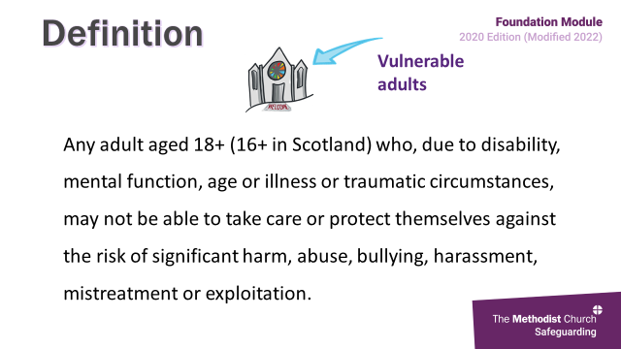

Faith organisations are among those named in legislation and statutory guidance as having a specific duty to safeguard and keep people safe. This means having appropriate arrangements in place to safeguard and promote the welfare of children, having relevant policies and procedures, training staff so they know how to respond appropriately to concern and working collaboratively with other agencies.

In order to safeguard within our churches, we need to follow the guidance on the slide. However, you will note that a number of these run through all 5 of the groups we will be looking at.

Further advice, information and guidance about working well and safely with children can be found in the Children, Youth & Family Ministry section of the Methodist Church website.

***Summary of the slide***

*In order to achieve good practice, we must:*

* *promote a safeguarding culture*
* *be alert to risk and take steps to keep children from harm*
* *act if we are concerned*
* *understand and follow policy and procedures*
* *make sure church premises are safe*
* *Know who to ask for guidance when we are not sure*

***Extra Information:*** *Statutory Guidance for the UK - Working Together to Safeguard Children: A guide to inter-agency working to safeguard and promote the welfare of children (2018)*

*Statutory Guidance for Scotland - National guidance for child protection in Scotland 2021*

*Working Together requires us to:*

* *protect children from maltreatment*
* *prevent impairment of children’s health or development*
* *ensure that children are growing up in circumstances consistent with the provision of safe and effective care*
* *take action to enable all children to have the best life chances.*

.

**Slide 10: Definition of a vulnerable adult 1 min**

 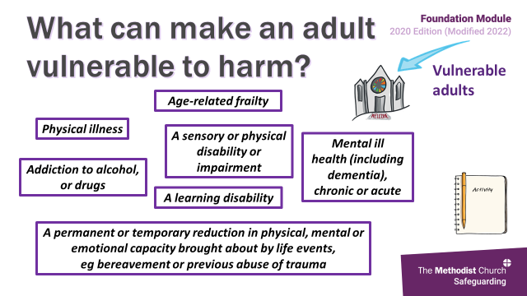

An adult may be defined as being vulnerable if they are aged 18 or over and are unable to look after themselves, protect themselves from harm or exploitation or are unable to report abuse. This vulnerability may be because of a mental or physical disability, age, illness or traumatic event. The Methodist Church has deliberately chosen this term because it recognises that although everyone is vulnerable in some way and at certain times, some people will have higher levels of vulnerability than others.

Remember that we also need to recognise that an individual may be describing or experiencing abuse even if they do not make it explicit.

**Slide 11: What can make an adult vulnerable? 6 mins**

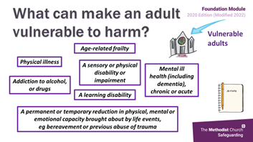 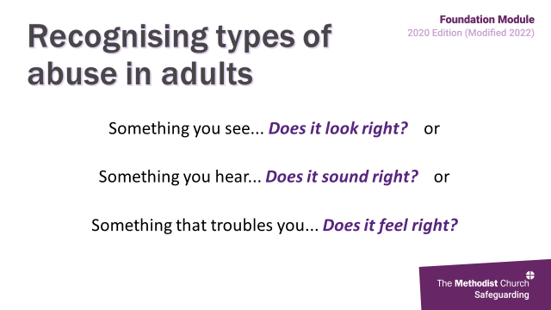

**Activity**

You’ll now undertake a short activity where we would like you to consider within your smaller groups anything that you feel may make someone vulnerable to harm. You will find a space for notes on **page 2 of your Workbook**.

*Groups of 4-6*

*Nominate a spokesperson*

*5 mins*

*Breakout groups of 4-6*

*Nominate a spokesperson*

*5 mins*

*On return, either bring up each of the boxes on the slide (which come up in 3 random groups) and ask if anyone had that answer or something similar; or ask for responses from participants and bring up the slide at the end as a summary.*

***Summarise that:***

* *Vulnerability is not always a permanent thing*
* *It is often not visible*
* *Even if a vulnerability is visible, the person may not perceive themselves as such*
* *Even those who are vulnerable themselves may pose a risk, and be capable of causing harm, to others.*
* *Often those who are vulnerable may be, or feel themselves to be, unable to do anything to protect themselves from harm, bullying or exploitation. We therefore have a responsibility to ensure that our churches are safe places for them.*

**Slide 12: Recognising abuse OR Slide 13: Video –**

**Vulnerable adults (7min 20)**

*(Only show this video if you are able to play the soundtrack)*

 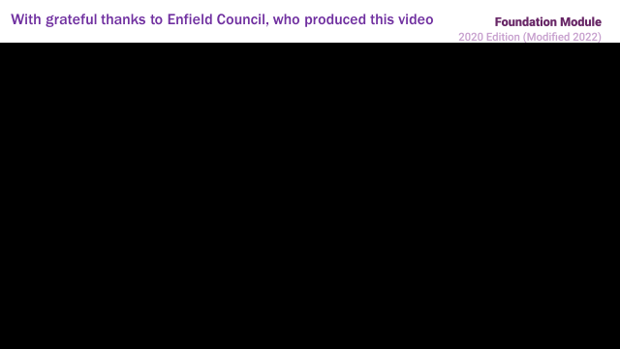

**10 mins**

We’re now going to watch a video, produced by Enfield Council, showing different aspects of adult abuse, although remember that many of these issues can also affect children.

Each type of abuse has a warning sign somewhere within the scene, so look out for them and think:

Does it look right?

Does it sound right?

Does it feel right?

**After the Video**

For the next couple of minutes we would like you to think of any other forms of abuse that you think were missing from the film and any other factors which may increase a person’s vulnerability. Just raise your hand if you have any suggestions.

We must always be alert to anything that would suggest an adult may be experiencing abuse or exploitation. Always think about:

Something you see

... Does it look right?

Something you hear

... Does it sound right?

Something that troubles you

... Does it feel right?

So, in your small groups just spend 5 mins considering what different types of abuse relating to adults you are aware of and other factors which may increase a person’s vulnerability.

*Brief feedback – aim for no more than 2 mins*

Forms of abuse to highlight:

*Spiritual abuse, domestic slavery, child sexual exploitation, human trafficking, forced marriage, FGM, cuckooing, gaslighting, county lines, disability, age, culture, immigration status,* *dependence*

In summary then, all abuse involves the misuse of power. There can frequently be overlaps between different types of abuse and there is often an emotional aspect to them all, including the witnessing of abuse. The 2021 Domestic Abuse Act clearly recognises children as victims of domestic abuse in their own right if they see, hear or experience the effects of such abuse.

**Slide 14: Good practice** **1 min**

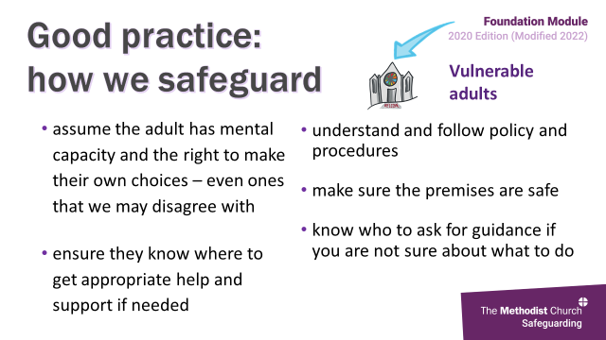 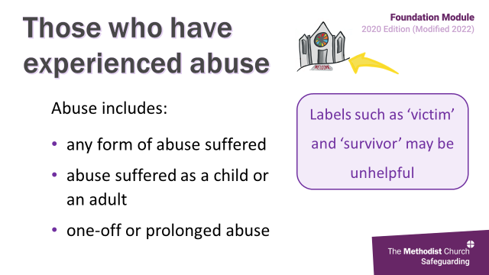

Safeguarding adults should be based on the assumption that the individual has the mental capacity to enable them to make informed decisions and the right to make their own choices, even if others do not agree with these decisions. Where you are unsure you must seek guidance from your safeguarding officer and/or DSO. There is more information about safeguarding adults and mental capacity on page 8 of the Handbook.

***Extra Information*** *on mental capacity can be found at:* [*https://www.scie.org.uk/mca/introduction/mental-capacity-act-2005-at-a-glance?gclid=EAIaIQobChMIyvqSprn95QIVx7HtCh0scAQsEAAYASAAEgLER_D_BwE*](https://www.scie.org.uk/mca/introduction/mental-capacity-act-2005-at-a-glance?gclid=EAIaIQobChMIyvqSprn95QIVx7HtCh0scAQsEAAYASAAEgLER_D_BwE)

**Slide 15: Those who have experienced abuse 1 min**

 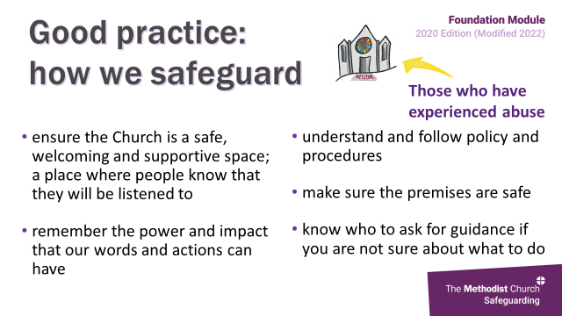

The term ‘survivor’ is often used in relation to those who have suffered abuse, but just because someone identifies as a ‘survivor’ does not necessarily mean that their recovery is complete. So often, labels and terms are not helpful as they can’t accurately represent an individual’s experience or personal journey. Therefore, we must be mindful of the language we use and remember that experience of abuse is very individual; it may relate to a one-off event, or multiple episodes, it may relate to abuse as a child or as an adult, occurring within the church or elsewhere and to whether support has been sought and how positive, or otherwise, the responses received were.

**Slide 16: Good practice 1 min**

 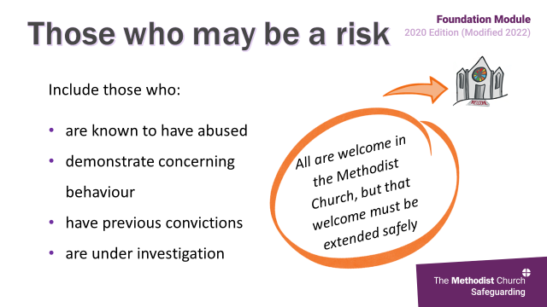

There will be adults and children within our Churches who have experienced abuse and are living with the impact it has on their lives and, as a Church, we have a responsibility to welcome and support them. This responsibility is not just for those who have experienced sexual abuse, nor only for those who have experienced church-based abuse, but for all.

The impact of abuse will be specific to each individual. It will depend on their personal circumstances, now and at the time of the abuse, as well as the nature of the abuse suffered and the identity of the abuser. Some will openly show the scars of their experience where other will not, some may appear to cope well with life where others do not. Nonetheless, the abuse will have a lasting impact on the rest of their life.

***Please note****: Trainers need to be careful not to let people start to talk from their personal or their church’s experiences about those who have been abused. If anyone wants to talk about this, direct them to the pastoral support. See Tips for maintaining appropriate boundaries on page 9 for more information***.**

**Slide 17: Those who may be a risk to others** **1 min**

 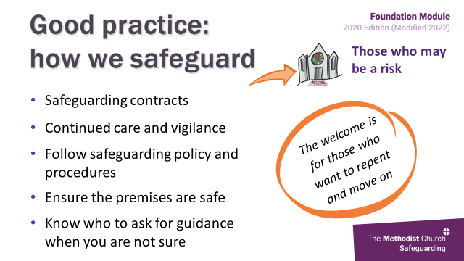

This includes those who are known to have abused or who have the potential to abuse. They may have been convicted of abuse previously, be under investigation currently or present a risk in other ways. One way in which we may identify such individuals is through our safer recruitment processes, another is from information shared from statutory agencies.

All are welcome within the Methodist Church, but that welcome must be extended safely. Welcoming those who have offended into the church can be a challenge for many people, and some people will try to use biblical text to rationalise their views

and opinions. The Faith and Order Committee presented to Methodist Conference a report entitled “The Theology of Safeguarding” within which they reflect theologically on the background and understanding of the challenges and tensions of welcoming all safely. If anyone would like a copy of the report please let us know and we will ensure a copy is emailed to you.

**Slide 18: Good practice 1 min**

 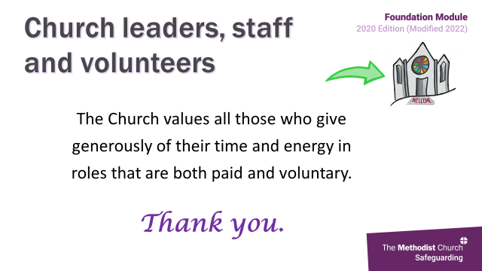

Within the Methodist Church we use Safeguarding Contracts with those who are identified as potentially posing a risk to others but who have a wish to change and participate in the life of the church. These safeguarding contracts are monitored to ensure that the risk is well managed, reviewed regularly and individuals supported by a small local group.

However, we do not always know that people are a risk to others, and it can be hard to recognise them. This is one reason for continued care and vigilance within the Church.

*It may be helpful to have read through the theological reflection activity on page 14 of the Advanced Module Essential Preparation material and/or The Theology of Safeguarding before delivering this section of the training.*

*If participants want more information about safeguarding contracts, signpost them to Section 4 of the Safeguarding Policy, Procedures and Guidance for the Methodist Church in Britain, or to their district safeguarding officer (DSO).*

**Slide 19:** **Church leaders, staff and volunteers 1 min**

 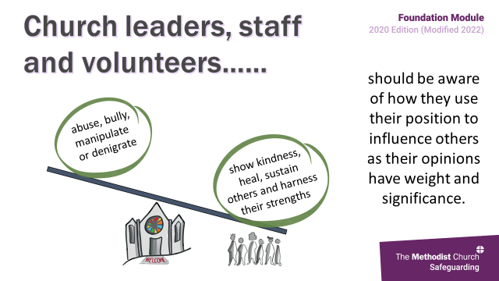

This is the new, 5th group that was added to the 2020 update, and recognises the value of Church leaders, staff and volunteers and the support they give to the church’s position within society and the community. For that we give grateful thanks to each and every one of you.

However, sometimes the roles we undertake in the name of the Church may leave us vulnerable, such as when supervising activities and people, or providing pastoral care.

**Slide 20: Church leaders, staff and volunteers (2) 1 min**

 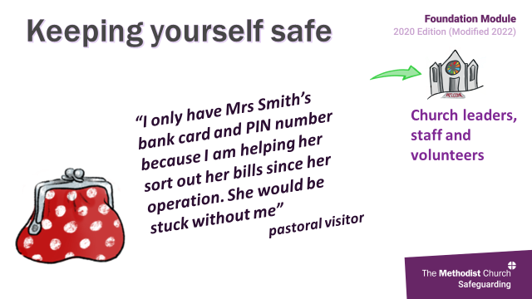

*(Animations on slide happen automatically)*

Even though we may not recognise it ourselves we, as Church leaders, staff and volunteers, may be viewed by others as having a degree of power and authority simply due to the roles we hold. This in turn can potentially lead to an imbalance of power within our relationships. Therefore, we need to be aware that our words and actions carry weight and significance and to ensure that trust in us well placed, and that we serve as positive role models.

**21. Keeping yourself safe 2 mins**

 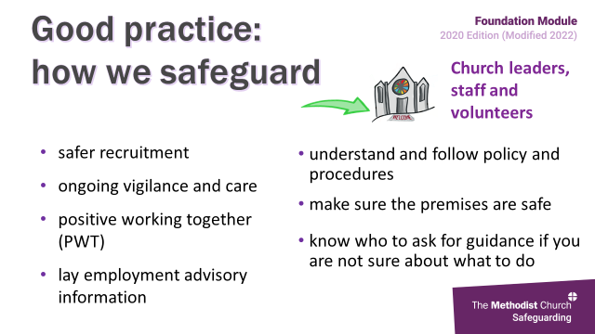

As in the example on the slide, we need to be aware of the risks if the boundaries of our roles slip, even if this is underpinned by good intentions, so it’s really important to recognise how and when what we do may make us more vulnerable, or our actions open to misinterpretation.

Therefore, we must remain alert to any potential risks, such as having Mrs Smith’s bank card and PIN above and remember always to refer to and follow policy guidance.

If you feel you may be vulnerable or if something changes within your role, even temporarily, you must speak with someone as soon as possible. This may be your minister, someone who coordinates pastoral care in your church, the church or circuit safeguarding officer.

**22. Good practice 2 mins**

 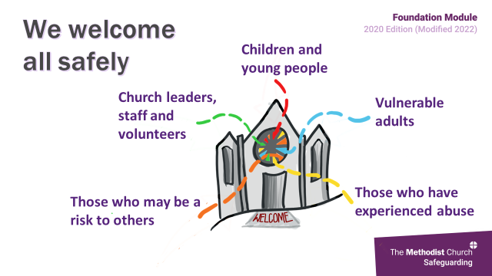

The slide shows some of the resources we have within the Methodist Church to support us, and it is important to remember that policies etc are in place to keep us and the wider Church safe.

Safer recruitment means we have a robust procedure and clear steps to follow when employing someone, whether paid or voluntary. It also means that the individual knows the scope and expectations of their role, stops them drifting into other areas of activity and ensures they receive regular support and review. By following policy and remaining vigilant, we are better placed to identify and screen out those whose intention is to abuse.

And it is important to recognise the dual challenges faced. Firstly, of hearing disclosures of abuse, and ensuring an appropriate response and secondly of managing the impact when a church leader, member of staff or volunteer is accused

*Trainers might want to highlight some of the policies and documents produced by the Methodist Church that are relevant to the safeguarding of church leaders, staff and volunteers. There is more detail about all of these in the Handbook:*

* ***Safer Recruitment – for volunteers and paid staff.*** *This practice guidance is intended to support the work of those in the Church who have responsibility for safely recruiting people who work with children and adults who are vulnerable.*
* ***Lay Employment Advisory Information*** *The purpose of this pack is to help churches, circuits and districts in the recruitment and selection of employees and in the early stages of employment. The pack also identifies some of the issues that can arise during the employment relationship and offers advice on these matters.*
* ***Positive Working Together (PWT)*** *This focuses on combatting bullying and harassment, which can be a source of conflict in the life of the Methodist Church.*

**23. We welcome all safely 2 mins**

 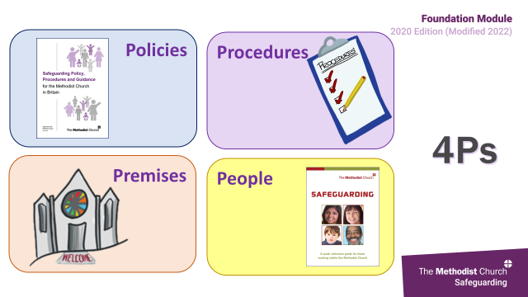

*(The animation on the slide plays automatically)*

This was a whistle-stop tour through the 5 groups and a reminder that there are very few places other than the Church which seek to strike a balance between them.

However, we must be aware that people may fall into one or more of these groups at the same time – adults who may be vulnerable can also be a risk to others; church leaders, staff and volunteers can also be vulnerable or may have experienced abuse.

So, this may be a good opportunity to jot down any notes or reflections on your learning log as a result of what we have looked at.

**Section 3: Good Practice (Slides 24-26, 33mins)**

**24. 4Ps 2 mins**

 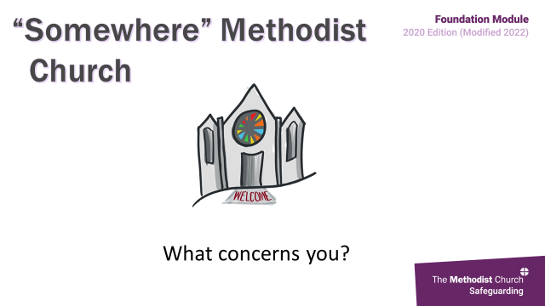

So how can we demonstrate good practice in terms of creating a safer space? This is where the 4 Ps of good practice come in. These are covered in more depth within your Handbook from ps15-20. However, we will summarise as a reminder.

Our Methodist safeguarding policies offers a framework to enable us to meet our safeguarding responsibilities whilst procedures tell us how we will do this practically within specific situations.

In order that our premises remain accessible to all, there are other aspects of church life with which safeguarding dovetails, such as health and safety and property. And we have already mentioned the importance of getting the right person for each role, using the safer recruitment principles to achieve this and give people more confidence in their role.

In this way we are supported in developing a culture of safety within which we transparently manage situations when things go wrong and are recognised as a learning Church.

Again, this is a great opportunity for you to identify your own responsibilities and whether there is anything that you need to go away and look up after this session.

Please remember that whenever you have a question about what to do or how to respond to a situation or challenge, the policies, both local and connexional, are available with many of the answers. You don’t have to figure it out on your own, you can instead go back to the policy – it will be your friend!

**25. “Somewhere” Methodist Church 8 mins**

 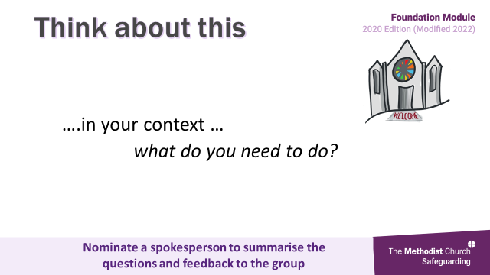

**Activity**

This next activity is designed to put into context some of the areas of good practice we have just looked at.

One of the Trainers will shortly present a Stewards report to the AGM at Somewhere Methodist Church and we’d like you to indicate where you think you have heard examples of either good or poor practice. You can find a written copy of this and space for notes on **page 3 of your Workbook**.

*Check that all the delegates know how to access the reactions button*

*Stop screen sharing, so that everyone can be seen.*

When you do, either just put your hand up or click the thumbs up button in reactions*.*

When you do, just put your hand up.

*One Trainer reads the ‘script’ and stops at the end of each paragraph as reactions are generated and the other asks different participants what the good or poor practice might be.* *The object of this exercise is not to spend time exploring each area of practice, but rather to acknowledge it.*

|  |  |
| --- | --- |
| **Somewhere Methodist Church** | **Issues** |
|  |  |
| A steward talks through his report on church activity at the Annual General Church Meeting: | |
| “Somewhere Methodist Church has a small but dedicated congregation and, as I always say, volunteers are so hard to come by, we can’t afford to be choosy, or to offend the ones we’ve got!  To be honest I am proud of this congregation’s efforts. | Safer recruitment  Confidence to challenge concerning behaviours |
| There’s the Browne sisters, Judy and Elaine. They work miracles with the youth club. They just open the hall and the kids come in off the streets, kids whose parents don’t even seem to care where they are. I go along about once a month, and I was so impressed last time as Elaine opened up by herself. Some of the kids helped her set up - getting equipment out of that dark cupboard – and some of it was really heavy. Judy arrived later looking very frazzled, she’d picked up some of the kids from the group, but they had been very loud in the car | Registration, consent, ratios  Lone working practice  Safer working practice  Health and safety  Transporting children |
| The Sunday school continues, although small in number. Pat Jones runs it almost single-handedly. I have no idea how many children have been through Sunday school in Pat’s time, a hundred or so I would guess. | Ratios  Register |
| And we’re very ‘with it’ at Somewhere Methodist Church, our youth leaders are on Facebook. There are lots of photos on there to look at and they tell me they are 'friends’ with most of the young people – great news! Not that I really understand what that means, except that the youth leaders are able help the youngsters anytime of the day or even night. | Social media policy  Photos  Safer working practices  Boundaries |
| Our community lunch club is going from strength to strength. We have so many wonderful people come along. Some are clients brought by the social services people and some people just turn up. It’s amazing how our volunteers make such hearty homemade food in that tired kitchen of ours! | Register/ratios  Vulnerabilities/additional needs?  Risk assessment  Health and safety |
| And love is in the air! Brian and Chris have announced they are getting married next week! Brian is our longest serving volunteer and he recently met the love of his dreams at our humble lunch club! Although Chris did play hard to get at first! They don’t say much, but Brian’s hugs seem to have won the day! I am sure we all want to extend our warmest wishes to the happy couple. We are so pleased that they found love here. | Boundaries  Safer recruitment  Appropriate relationships  Coercion/ control/ power  Possibility of predatory marriage |
| And there is Florence – where would we be without the beautiful flowers she arranges each week? Florence is so dedicated that when she went to stay with her daughter for a few weeks she arranged for two or three of her neighbours to have the church key and pop in with the flowers. So thoughtful of her. | Possible lone working  Risk assessments/planning  Keys |
| Although we have struggled with finances over the past few years that is all a lot easier now we are letting out the hall. There are quite a few groups coming in – dance classes, flower arranging clubs, music groups. And all without creating much extra work. There are no complicated forms, they just give me the money, I record it in the book and give them a key – job done! | Lettings policy  Health and Safety  Insurance  Keys |
| Now, before I finish, we’ve had this email from the District Safeguarding Officer telling us what we should do if someone tells us they have been abused in the past. We don’t have to worry about that sort of thing here, we all know each other so well, I am sure we would know already. But the information’s at the back if you want it. | Understanding that safeguarding is everyone’s responsibility and can happen in any church  Respectful uncertainty  Supporting those who have experienced abuse. |
| So as you see things are going well - thanks to everyone’s commitment.” | |

Hopefully, we are all now aware that following good practice is not about having rules and regulations in order to stop people from doing things, but instead it is about working together to enable everyone to get the most out of their church and community in safe and enjoyable ways. Taking steps to promote a wider culture of safeguarding in all our churches is an important recommendation from the Past Cases Review. More information about this important report can be found in Appendix 1 (page 28) of your Handbook.

**26. Your context 8 mins**

 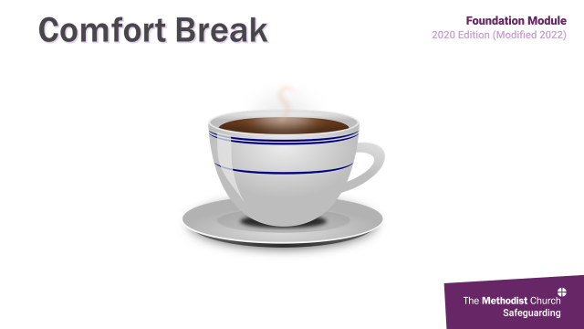

**Activity**

Now we’re going to send you back into your groups to discuss any aspects where you feel your practice, or practice within your church, may need to be reviewed again and remember you’ll need to nominate a spokesperson.. Again, remember to make notes of any actions you need to take when you get back on your learning logs.

You’ll have 5 mins in your groups and then quick feedback. *Aim for no longer than 2 mins*

**27. Comfort break 10 mins**

 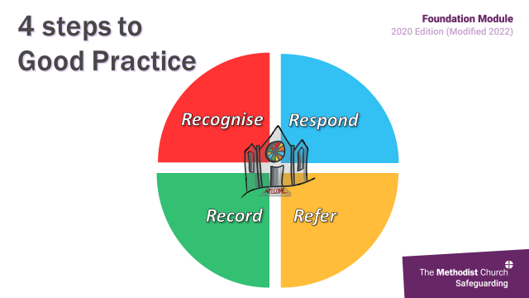

**Section 4: Four steps to good practice (slides 28-35) 39mins**

**28. 4 steps to good practice 1 min**

 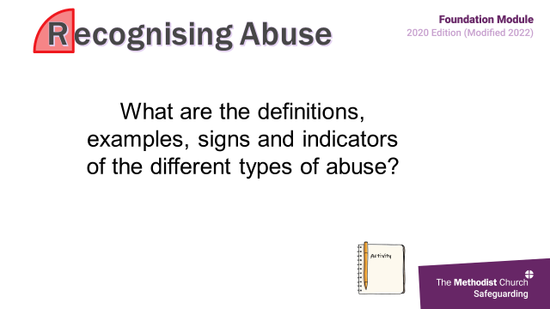

We are now moving on from the 4Ps of good practice to look at the 4 Rs, which are universal in safeguarding and help us to act if we have concerns about someone’s safety or welfare. These are covered within p 21-26 of your handbook.

These 4 steps are:

* **Recognise** the concern
* **Respond** well by doing what we need to do at the right time and acting in an open and transparent way
* **Record** what has been seen, heard or said
* **Refer/Report** or share the concern with the appropriate people

And perhaps we should also add a 5th: responsibility, because safeguarding is everyone’s responsibility.

**29. Recognise 13 mins (1min intro 10 mins activity 2 min summing up)**

 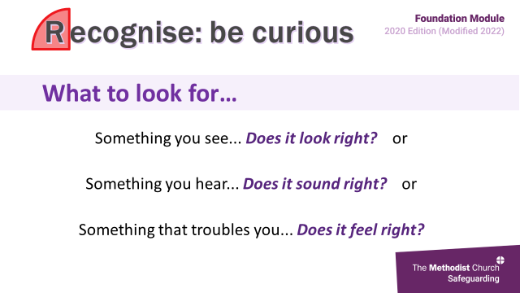

***Please Note:*** *There may be those who have experienced abuse within the training group, so please be sensitive in this section. Remind participants to look after themselves and to opt of activities if that is better for them.*

Abuse is the violation of an individual’s human and civil rights by another person or persons. It comes from the misuse of power and control that someone has over another. Harm is the result of this mistreatment or abuse. Abuse may consist of a single act or many repeated acts, and it can occur in any relationship at any time of life. Any, or all types of abuse may be perpetrated as the result of deliberate intent, negligence or ignorance.

Abuse can take many forms.

It can be:

● physical

● sexual

● emotional

● neglect (including self-neglect)

● financial (or material)

● spiritual

● discriminatory

● institutional

● domestic

● online

● modern slavery

● exploitive

● radicalisation

● bullying and harassment.

**Activity – types of abuse**

**Face to Face session**

*Place flipchart paper and marker pens around the room. On each piece of flipchart paper write a type of abuse as a heading. Don’t try to do them all, but choose those which you think are most relevant to the group.*

*We recommend that you choose 4 or 5 different types of abuse, but please ensure that you always cover sexual abuse, domestic abuse and financial abuse.*

We are going to think about the indicators of some forms of abuse. Around the rooms are flipchart sheets with different headings. Please move around the room and write something on each piece of paper – no matter how little you feel you know about that type of abuse. Write as many different points as you would like but remember this is not a test. There will be 10 minutes for you to complete this activity.

*Please note that due to the use of language, writing and movement around the room, adjustments may need to be made to ensure that the activity is fully accessible by all. Please adjust the activity in response to your group’s requirements.*

**Online session**

*While the whole group are still together, write into the chat, 4 or 5 different types of abuse which you think are most relevant to the group. Please ensure that you always cover sexual abuse, domestic abuse and financial abuse.*

We are going to think about the indicators of some forms of abuse focussing on *name the different types of abuse* which are also listed in the chat. In your breakout rooms think about what some of the indicators of each type of abuse might be. Think of as many different points as you would like but remember this is not a test. There will be 8 minutes for your conversations.

*Draw the group back together and encourage them to look at their Handbooks, (Appendix 2, pages 30 to 41).*

**30. Recognise: be curious 1 min**

 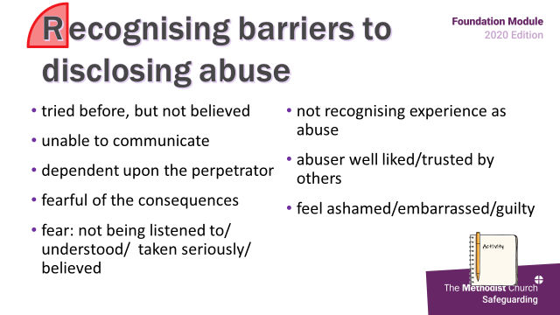

*NB This may be a review of slide 12*

There is more information on p21 of your handbook looking at who may inflict abuse and where, and types of abuse, which is further expanded upon in appendix 2 at p30.

The key thing to remember is that any individual, from any background, can be at risk of abuse, but that some people are more vulnerable than others and at different times. For example, when a family is going through a tough time, parents and carers might find it more difficult to meet all the physical and emotional needs of their child/ren for a short period, whilst they adapt to their own change in circumstances. This is where the support of the family of the church may be required.

**31. Recognising barriers to disclosing abuse 5 mins**

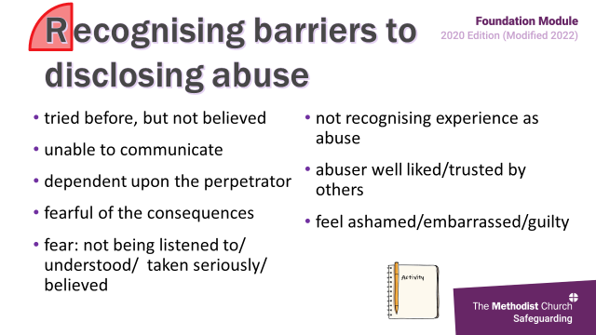 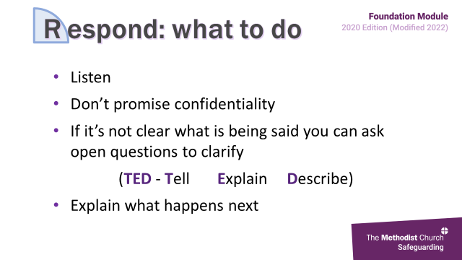

*Don’t click slide on or answers will appear*

**Activity**

Now we’ll move onto to think about what factors may stop someone from disclosing abuse.

*When finished click the slide again to bring up the list and briefly refer to those not identified.* *They can find a space for notes on page 5 of their Workbooks.*

*Hands up and shout out*

*or*

*write in chat*

*Nominate a spokesperson*

*Hands up and shout out*

*or*

*use flip chart*

*Nominate a spokesperson*

So, because there are barriers which may stop individuals from disclosing, we need to remember to remain vigilant for things which don’t look, sound or feel right, and ensure we are open to people feeling able to tell us their stories.

*Be prepared to bring out examples that might help the group’s discussion. For example, domestic abuse cases when a child is abusing the parent and why the parent might not want to disclose that abuse, or someone trapped in modern slavery who doesn’t speak English or know where to get help. You may also want to highlight the increased vulnerability of children and adults with disabilities.*

***Please Note:*** *There may be those who have experienced abuse within the training group, so please be sensitive when exploring this question.*

***Slide content:***

* *not knowing it is wrong*
* *being unable to communicate**: child: age, adult: stroke, English not 1st language, no word in their language to describe abuse*
* *being dependent upon the perpetrator*
* *having tried to tell before without success*
* *being fearful of the consequences*
* *feeling ashamed/embarrassed /guilty*
* *fearing they won’t be listened to /understood /taken seriously /believed.*

**32. Respond: what to do 2 mins**

 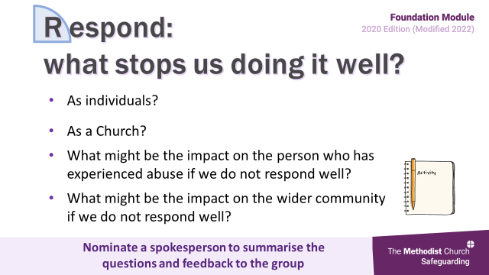

This slide is about what responding well looks like and recognising what may get in the way. Research and reviews tell us that the most important thing we can do is to provide a listening ear, hear well and give someone the choice to tell their story in their own way.

Remember this is not about promising to keep secrets but being clear and transparent about what information may need to be shared and with whom to manage the situation safely.

With adults it is always best practice to seek and record their consent to share information but be clear that this information may have to be shared, even if they don’t consent, if there is a risk of significant harm or it in the public interest. Consent is not required in respect of children, but again best practice is that the family be told.

If you’re not clear about what you think you are hearing, then ask open questions. These are to help the individual relate their story, not to get more information – do not try to investigate. For clarification, feedback by saying something like “am I right in thinking you said…” or “so you mean that…..”

The TED acronym is also useful to use -**Tell** me, **Explain** to me, **Describe** for me (**TED**).

Then you need to explain what will happen next, what you are going tell and to whom and give them a timescale. Remember that you should always seek advice if you have any concerns and don’t know what to do.

**33. Respond: what stops us doing it well? 12 mins**

 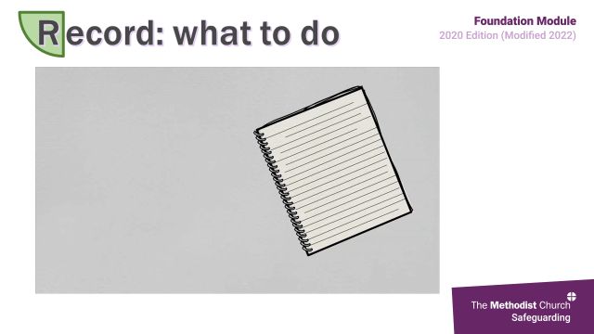

**Activity**

We just considered what responding well looks like, but there may be barriers that get in the way, so we’ll try to identify some of these factors by responding to the following questions:

What things may get in the way for us as individuals?

What things may get in the way for us as a Church?

What may the impact be on the person who has experienced abuse if we don’t respond well?

What may the impact be on the wider community if we don’t respond well?

Now we’re going to send you back into your groups to consider the questions on the slide. You will find a space for notes on **page 6 of your Workbook**.

*Breakout groups of 4-6*

*Depending on numbers, each group to consider one or more of the categories*

*Nominate a spokesperson who makes notes to feed back*

*8 mins*

*Groups of 4-6*

*Depending on numbers, each group to consider one or more of the categories*

*Write on flip chart/make notes*

*Nominate a spokesperson*

*8 mins*

*You may need to remind them about how the church links with the community e.g. room hire, social and fund-raising activities, ecumenical contacts*

**Feedback** *– ensure all the factors below are covered.* ***4 mins***

|  |  |  |  |
| --- | --- | --- | --- |
| *Things that may get in the way for us as* ***individuals****:* | | *Things that may get in the way for us as a* ***Church:*** | |
| * *don’t want to hear* * *fear we may be wrong/ fear we may be right* * *feelings of anger/distress/guilt* * *embarrassment* * *doubts about truthfulness* * *don’t believe: not using respectful uncertainty* | * *not want to be seen as a busybody asked not to tell* * *finding another explanation for the behaviour* * *not wanting to interfere* * *uncertainty about procedures and consequences.* | * *don’t want to hear* * *denial: this doesn’t happen in our church* * *the person/family is well respected/ is a good person* * *a desire for it to be kept in the church* * *limits of confidentiality and confession are misunderstood* | * *confusion about false allegations* * *not knowing who to consult or where to get help* * *the church is about forgiveness and not condemnation.* * *not having the right people in the right roles tick box response to recruitment* |
| *Impact on the person who has experienced abuse:* | | *Impact on the wider community:* | |
| * *feel more vulnerable, exposed* * *distress, betrayed, angry* * *confirming the belief that no one will listen or believe it has happened* * *concern that others will be hurt* * *make it more difficult to speak out again* * *make situation worse* | * *loss/questioning of faith* * *loss of a safe space* * *ongoing issues e.g. mental health, self-harming, low esteem* * *lifelong negative impact on all relationships* | * *reputational damage – to the local church, circuit, the Methodist Church connexionally, Christianity, or to the reputation of the local community* * *reinforce negative stereotypes of the church/ministers: cover up, what do you expect…* * *loss of a safe space* * *anger* | * *split in the community, taking sides* * *judgement – extra betrayal/ worse when the church gets it wrong* * *anxiety/pain/distress* * *less trust in the church* * *bad publicity* * *loss of external bookings and income* |

*You may want to pick up on the question of false allegations. Research suggests that the level of false allegations within safeguarding concerns is the same as for other crimes at about three per cent. The best way to identify a false allegation is to respond exactly as you would for genuine concerns. This way, inconsistencies, flaws and gaps should quickly become apparent. The worse way to respond is to block the concern, because then no-one’s interests are protected.*

**34. Record Video (3 mins 7) 4 mins**

 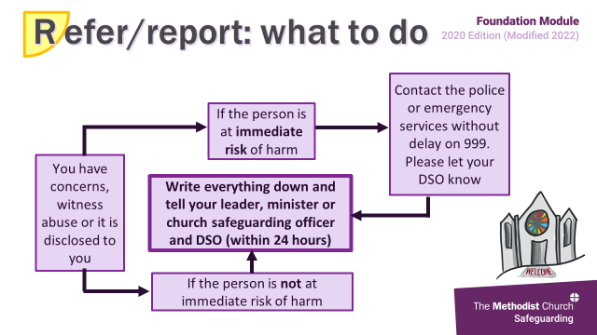

This next short video gives a brief synopsis of the process for recording.

(*Click on the arrow in bottom left corner of the grey rectangle to start the video)*

**After the video**

So, remember that records provide a history of what has happened, helps build a picture and means that the information is not lost if someone moves on.

Also remember that all records must be kept in a secure place. The Connexional *Safeguarding Policy, Procedure and Guidance for the Methodist Church in Britain* has more information about keeping records and when to share them. Use full names, title, job roles etc: remember 5 or 10 years on people may not know who is being referred to.

*It is common for participants to ask about an official form to record their observations. Explain that at this level we are asking people to record their concerns and niggles that they have as well as any disclosures. Not all the information will be known, and experience tells us that people are less likely to record a niggle or a gut feeling if they must then complete a form. The important thing to remember is to write a record of what you have recognised, no matter how small or seemingly inconsequential it may appear.*

**35. Refer/report: what to do 1 min**

 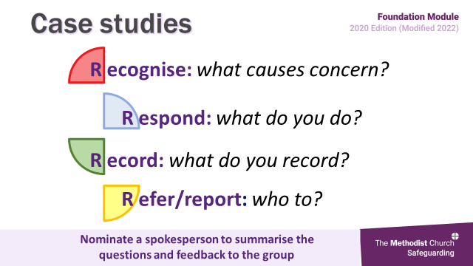

This slide shows how concerns should be shared appropriately, often called referring or reporting so it is important that you know who this is within your own churches and circuits. Remember to complete the details on the Safeguarding quick reference guide you received with your resources.

If someone is at immediate risk your first action must be to notify the emergency and/or statutory services, then let your DSO know. This can provoke huge anxiety for us but remember that you can always access support.

Thereafter, or if there is no immediate risk, you need to record your concerns and inform within 24 hours the relevant people. These may be one or more of the Minister, church or circuit safeguarding officer or District Safeguarding Officer.

More detailed flowcharts can be found Connexional Safeguarding Policy.

*You may want to acknowledge the level of anxiety within churches about contacting professionals such as the police or social services. In some cases, this can extend to not informing church, circuit or district safeguarding officers or not contacting them for advice. You should respect people’s anxiety whilst insisting that the right action is taken every time. Emphasise that ‘right action’ means never acting in isolation and always having support.*

**Section 5: Case Studies (slide 36) 20 mins**

**36. Case studies**

 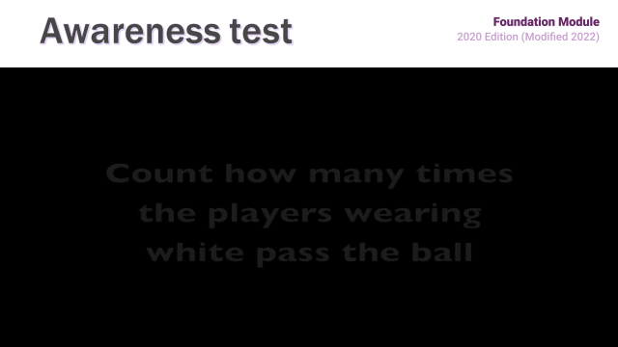

*Groups of 4-6*

*Depending on numbers, each group to consider one or more of the scenarios*

*Nominate a spokesperson to feed back*

*10 mins*

*Breakout groups of 4-6*

*Depending on numbers, each group to consider one or more of the scenarios*

*Nominate a spokesperson to feed back*

*10 mins*

You are now going back into your smaller groups to put the 4 Rs into practice by looking at a number of scenarios which we will allocate to you. You will have 10 mins before we come back together. You will find a space for notes on **page 7** of your Workbook and the written case studies from **page 8**.

As well as thinking about the 4 Rs – recognise, respond, record and refer - also discuss how you felt you when you read it.

Within these case studies you may see things that are clearly safeguarding issues, issues that may suggest safeguarding issues and/or things that, if we respond appropriately at the time may reduce the risk of a safeguarding situation developing. Some may not be safeguarding issues at all but will need to be managed by someone else within the church. So, you have a lot to think about.

*Spend 10mins together for feedback*

**Summarise**

This activity reminds us of the importance of the 4 Rs, that safeguarding is everyone’s responsibility, what our own responsibility is and hopefully, that you are never alone in thinking through something that could be a concern.

**Section 6: Reflection, Evaluation and Close (slides 37- 44) 13 mins**

**37. Awareness test 3 min**

 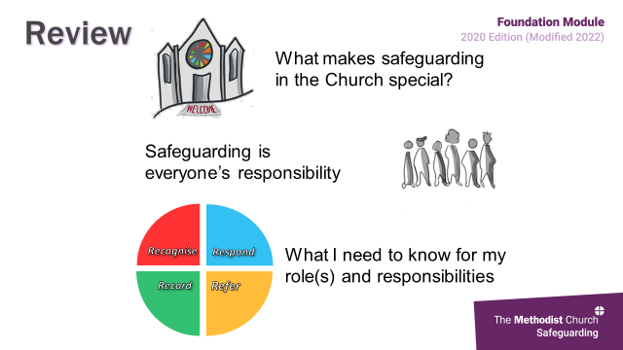

We’ll now show you a quick video *(1 min 30)* to see how observant you are.

**After the video**

Isn’t it easy to miss something if you’re not looking for it!! And it’s the same for signs of abuse or harm.

We all view things in a variety of ways and focus on different things, so we need to remain alert and let others know if we see something that worries us. We can’t assume that someone else has or will.

What so many of the Serious Case Reviews into the death or significant harm to children have told us is that so many of these deaths or injuries were preventable but that often these children were invisible to services, there were a number of missed opportunities to take action that may have changed the outcome and a lack of joined up working.

|  |  |  |  |
| --- | --- | --- | --- |
| Victoria Climbie | 2000 | 8 years | 128 separate injuries and scars on her body  known to four local authorities (four social services departments and three housing departments), two child protection police teams, two hospitals, an NSPCC centre, and a few local churches. |
| Peter Connelly | 2007 | 17 months | 50 separate injuries  Medical concerns shared, multiagency involvement |
| Khyra Ishaq | 2008 | 10 years | Starved. Paternal history of extreme abuse as child, strong belief in evil spirits |
| Daniel Pelka | 2012 | 4 years | 22 different types of injuries, 10 of which were severe and to the head. The cause of death was determined to be a brain injury. Also severely malnourished, family history of DAV |
| Ayesha Ali | 2015 | 8 years | Online interactions - religious adviser Skyman, a Muslim spiritual guide who claimed Ayesha was "evil", horrific levels of mental abuse, escalating to physical. |
| Ellie Butler | 2016 | 6 years | Suffered fatal head injuries |
| Ayeeshia Jane Smith | 2016 | 21 months | Car crash like injuries |
| Arthur Labinjo- Hughes | 2020 | 6yrs | Severely beaten - "an unsurvivable brain injury” |
| Star Hobson | 2020 | 16 months | Suffered weeks of physical abuse before the fatal assault. |

Sadly, this list will probably be out of date as the abuse continues, that is why this training is so important.

**38. Review** **1 min**

 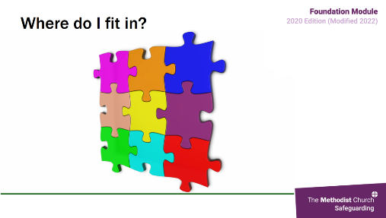

The three key things that we would like you to take from today’s session are:

* That safeguarding is everyone’s responsibility
* how safeguarding impacts the unique context of the Church, and what you need to know for your specific role(s) and area of responsibility
* The four Rs – Recognise, Respond, Report, Refer**.**

**39. Where do I fit in? 1 min**

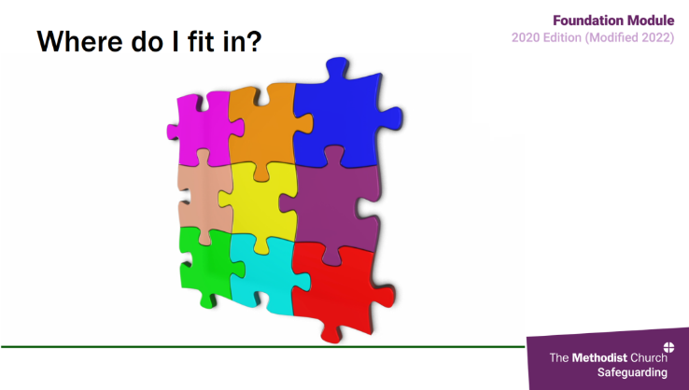 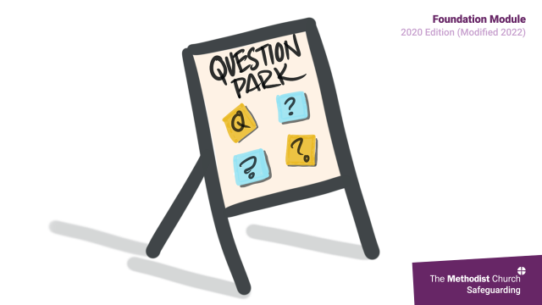

Video – don’t click, it will play by itself (15 seconds)

When we construct a jigsaw it is easy to see what some of the pieces represent. This may be the case with some information that we have. We can see quite clearly that we need to pass this information on to the emergency services and leader, minister or church safeguarding officer. Other pieces are not so clear and may niggle us, as we think we know they fit somewhere but are not sure what to do with them right away.

Remember that it is important to pass on all information to your leader, minister or church safeguarding officer. It is that person’s responsibility to then pass that information on to the circuit, district, connexion and statutory authorities, who will be building up the big picture. The more pieces of the jigsaw that they have, the easier it is for them to see the picture.

Sometimes there are pieces of the jigsaw missing; these could represent information that is coming from unexpected sources other than known professionals. For example, the general public, volunteers, **church members** etc.

**40. Question park 2 mins**

 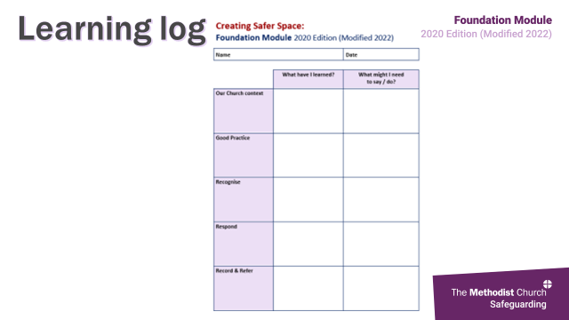

Now we’ll check if there are any questions on the Question Park.

**41. Learning log 1 min**

 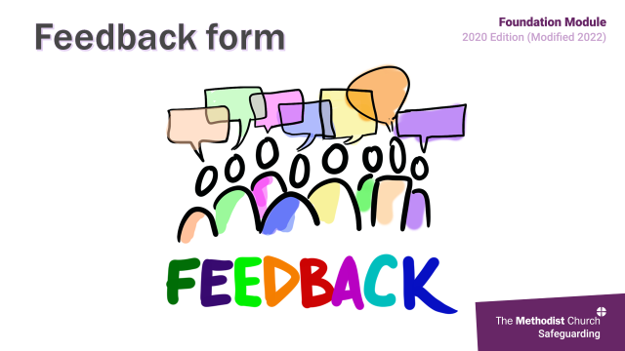

Don’t forget to use your learning logs to record the impact the training has had on you and anything you need to do within your roles and responsibilities. As we said at the beginning, your learning about this topic is not just about this session alone, it is about reflecting on how we can change our practice, develop our procedures and make a priority of ensuring our spaces are safe for all people to be present in.

**42. Feedback form 1 min**

 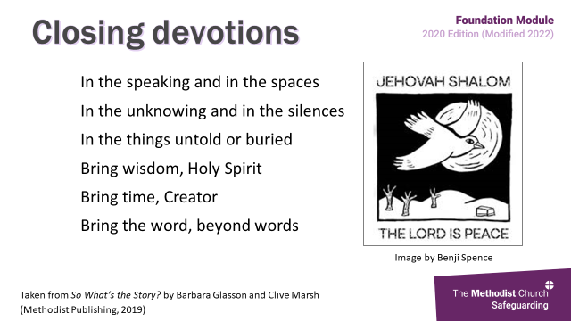

*Advise about certificates and feedback forms*

We will email out to you both a feedback form, which we would be really grateful if you could complete and return as indicated, and your certificate of attendance.

You have been given feedback forms and we would be really grateful if you could complete these before you leave.

Certificates of attendance are available as you leave, so don’t forget to take yours with you.

**43. Closing devotions 3 mins**

 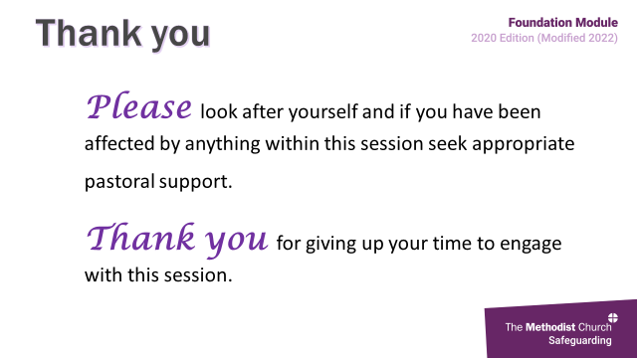

*You can use one of a number of different prayers that have been specifically written or chosen for this session (see next few pages), or share the Grace together, or perhaps use a prayer or reading of your own.*

**44. Thank you 1 min**



Final slide

***Optional Devotions***

**1.** **Prayer for volunteers**

Loving Creator, we thank you for the volunteers who are willing to come and serve in places that are not always easy.

These are the places where Your love and their love is needed most.

Loving Creator, we thank you that your Church is working to offer places of welcome, understanding and safety to all who have experience of abuse in any of its myriad forms.

These are the places where Your discernment and their discernment is needed most.

Loving Creator, we pray that our communities may be places of safety and joy, as we delight in your gift of life,

and grow in the grace and knowledge of our Lord Jesus Christ. **Amen**

**2.** **Glasson and Marsh**

In the speaking and in the spaces

In the unknowing and in the silences

In the things untold or buried

Bring wisdom, Holy Spirit

Bring time, Creator

Bring the word, beyond words

Taken from *So What’s the Story?* by Barbara Glasson and Clive Marsh (Methodist Publishing, 2019)

**3.** **The Northumbria Community**

Calm me, O Lord, as You stilled the storm.  
Still me, O Lord, keep me from harm.  
Let all the tumult within me cease.  
Enfold me, Lord, in Your peace.

Father, bless the work that is done, and the work that is to be.

Father, bless the servant that I am, and the servant that I will be.

Thou Lord and God of power, shield and sustain me this night.

I will lie down this night with God, and God will lie down with me;  
I will lie down this night with Christ, and Christ will lie down with me;  
I will lie down this night with the Spirit, and the Spirit will lie down with me;  
God and Christ and the Spirit, be lying down with me.

The peace of God  
be over me to shelter me,

under me to uphold me,

about me to protect me,

behind me to direct me,

ever with me to save me.

The peace of all peace be mine this night

In the name of the Father, and of the Son, and of the Holy Spirit.  
**Amen.**

**4.** **The Advisory Group – Survivors of abuse**

God of Justice, we pray for a church where so many have been let down.

A church that has stayed silent in the face of abuse and

a church that has passed by on the other side.

We pray for sincere and committed people who can open their hearts to the silenced,

the betrayed, the frightened and lost

and who more truly reflect your Kingdom of Heaven.

Loving God

Help us this day to find you, to experience your loving attention,

despite all the rejection and pain which has been placed in our way.

**Amen.**

**5.** **Prayer of the Survivors’ Group of the Methodist Church**

Lord God we thank you that you have brought each one of us to this moment in our journey of life, we thank you that you make each one of us equal in your world, we thank you that you value each one of us, love us and care about us and ask us to value each other, and respect each other.

As we gather Lord to think about those who do not respect others, those who abuse in any way, without regard for those they prey on, we ask you to open our minds and ears to hear how we can better safeguard, not just in our places of worship but in all parts of our lives.

Lord guide us, surround us with your love, and give us grace to be aware of each other as we share in this difficult subject.

Lord we offer this time to you now and pray that as we learn we may become aware that safeguarding is a way of life and not a tick box, and that these issues are not just things that happen to someone else, but issues that can happen in any situation, with any person at any time.

We offer our prayer through our everlasting, ever loving Lord Jesus Christ, **Amen**

**6.** **Every step of the way**

Wherever you go

Whatever you do

The paths you take

The decisions you make

The learning you have

The awareness you gain

Just when you think you are alone

And it is all up to you

Open your eyes

Prick up your ears

And feel my presence

For I have been there throughout

Whichever way you choose to go

I am there before you

Now

Before

After

[*www.inbetweenthewords.co.uk*](http://www.inbetweenthewords.co.uk)

**Appendix 1**

**CASE STUDIES SUMMARY**

***1.* GLORIA -** Issues include disclosure of non-recent sexual abuse

**2. TASHA -** Issues include boundaries, confidentiality and possible disclosure of abuse

**3. JUNE & SALLY** - Issues include domestic abuse, confidentiality and threat of suicide

**4. KEN -** Issues include possible downloading of indecent images and suitability as local preacher and youth worker

**5**. **JAMES** - Issues include welcoming those who might be a risk and Monitoring & Support Groups

**6. REBECCA** - Issues include domestic abuse (coercive control) including impact on children

**7. BENITA** - Issues include misuse of premises, key holders and policy with external lettings

**8. JASMINE** - Issues include grooming and policy of ratios for overnight trip

**9. RITA** - Issues include possible Power of Attorney, developing dementia and financial abuse

**10. ABDUL** - Issues include spiritual abuse and abuse of power

**11. GRACE** - Issues include institutional abuse

**12. JOSH AND BEN** - Issues include online grooming

**13. KYLIE AND ASHER** - Issues include neglect

**14. DESMOND** - Issues include financial and online abuse

**15. KIM** - Issues include modern slavery

***CASE STUDIES (1): GLORIA***

***Issues include disclosure of non-recent sexual abuse***

You are a pastoral visitor, and pop in to see Gloria who hasn’t been to Church for a few weeks. Gloria is very distressed, she has heard that her niece (now 8yrs old) has gone to stay with her grandparents, Mark and Claire for a few weeks, whilst her mum is in hospital. Gloria is worried for her niece and explains that when she was little Mark sexually abused her, and she worries the same will happen to her niece. However she has never told anyone and is scared of what would happen to the family if she did.

**RECOGNISE:** *Issues of concern you would hope to hear in feedback:*

**Gloria:** Her worry, distress and unhappiness - Her experiences of abuse - Her fear of what will happen is she speaks out

**Niece:** Potential risk of sexual abuse- Mother going into hospital

**RESPOND:**

**Feelings:** *Feelings might be evoked in the answer to this question - all these are valid feelings and might need to be explored.*

**Response to Gloria**

* Listening to Gloria with care, ask open, clarifying questions
* Being clear about the limits of confidentiality
* Be open to hearing what she says
* Ask Gloria what she would like to happen
* Agreeing next steps

**RECORD**: *Answers you would hope for:*

* Date and time of visit
* The content of the discussion during the visit – names of Mark and Niece
* Any actions taken.

**REFER:** *Answers you would hope for:*

* The minister/ the church safeguarding officer.
* Discuss with the DSO about a possible referral to Children’s social care/ Police

**A helpful answer** would be that course participants would want to support Gloria to talk to someone else such as the minister.

An **unhelpful answer** may include assumptions about what has/ hasn’t occurred. Any response that sees the group seeking to resolve this issue without the full support of the District Safeguarding Officer. Any response that indicate that they would not seek to be involved.

If possible, point out this may trigger a response to trauma if Gloria has not already dealt with this, even though it is a long time ago, and it may make her a vulnerable adult at this point.

***CASE STUDIES (2): TASHA***

***Issues include boundaries, confidentiality and possible disclosure of abuse***

You are a youth club worker. One dayGabrielle, ayouth club volunteer talks to you with concerns about Tasha (14 years), who has cerebral palsy and attends youth club regularly. Gabrielle tells you that Tasha has been messaging her at all hours of the day and night mostly talking about how unhappy she is at home. Tasha has hinted there is something she needs to say about her stepfather that she does not want anyone to know because it is too embarrassing, so she would like to text it. She wants Gabrielle to promise not to tell anyone else about it. Gabrielle asks you what she should do,

**RECOGNISE**: *Issues of concern you would hope to hear in feedback:*

**Gabrielle:** Contact outside of Youth Club – issues of boundaries

**Tasha.** Her unhappiness. Being secretive. Worried about something she is too embarrassed to talk about. Is there any pressure being put on Tasha to keep the silent? Impact of spending so much time in contact with Gabrielle.

This might be a real concern relating to abuse/ criminal offence, but it might transpire that it is an issue that does not pose a risk to Tasha. However, Gabrielle’s blurring of boundaries complicates the situation by confusing how Tasha sees Gabrielle and may leave her vulnerable to allegations.

**RESPOND**:

**Feelings:** *Feelings might be evoked in the answer to this question - all these are valid feelings and might need to be explored.*

|  |  |
| --- | --- |
| **Response to Tasha**   * Listening to Tasha with care * Being clear about the limits of confidentiality * Not asking leading questions * Not jumping to conclusions * Not being judgemental * Using respectful uncertainty. | **Response to Gabrielle**   * Listening to Gabrielle with care * Being clear about the limits of confidentiality * Discussing boundaries within role at youth group * Discussing the social media policy * Agreeing the next steps. |

**RECORD**: *Answers you would hope for:*

* Date and time of messages
* The content of the messages, what Tasha said and what Gabrielle said
* The names of those that know about the messages
* That you had a discussion with Gabrielle around boundaries and social media policy and her response - Any actions taken.

**REFER**: *Answers you would hope for:*

* The youth club leader/ the minister/ the church safeguarding officer.

**A helpful answer** would be that course participants would want to support Tasha to talk to someone else such as the minister/ youth club leader or to help her make a positive decision to share her messages.

**An Unhelpfu**l might include: Gabrielle being encouraged to continue a relationship with Tasha outside of the youth club - including ongoing social media contact. A response that colludes with secretive behaviours. Go to the police or social services without discussing with safeguarding lead. Talk to Tasha’s stepfather. Assumptions about what has/ hasn’t occurred.

***CASE STUDIES (3): JUNE & SALLY***

***Issues include domestic abuse, confidentiality and threat of suicide***

You are pastoral visitor for June (85yrs) and Sally (60yrs) they are a mother and daughter, who have lived together for the past 40 years as Sally has a learning disability and needs ongoing support. Two months ago, June broke her hip in an incident in the home, and on discharge from hospital was sent to a care home 100 miles away, leaving Sally living on her own. You visit Sally who says that she is missing her mum terribly, she hasn’t had any contact with her for weeks and she talks about feeling depressed and suicidal. You are very concerned and raise Sally’s situation with the minister, who tells you that June has recently been in contact to say she is frightened of Sally, who has physically abused her for many years, and that she does not want her to know where she is.

**RECOGNISE:** *Issues of concern you would hope to hear in feedback:*

|  |  |
| --- | --- |
| **Sally**   * A vulnerable adult with a learning disability and needing ongoing support * Injury to her mum may have been traumatic * Distressed that she can’t see her mum * Talking about feeling depressed and suicidal * May have been harming her mum. | **June**   * Has made a clear statement that she has been harmed by her daughter * Has suffered a serious injury and is living away from her community networks * Has a right to privacy and for her information to be kept confidential * Recognise that domestic abuse can be hidden, and anyone can be a perpetrator. |

**RESPOND:** *Feelings might be evoked in the answer to this question - all these are valid feelings and might need to be explored.*

* Ensure confidentiality – don’t share information with Sally
* Check with Sally that she has the support she needs to live independently – are social services involved?
* Think about pastoral support for Sally to help with the loss of a relationship with her mother
* Think about where June is, and whether she has or wants support from a local church
* Consider if there is a need for a risk assessment for lone working with Sally
* Consider if there are any concerns about Sally’s behaviour towards other members of the church – is there a need to consider a safeguarding contract?
* Seek advice from the District Safeguarding Officer.

**RECORD**: *Answers you would hope for:*

* Date and time of information shared
* Content of the information shared
* What support has been offered to Sally and/or June
* Who is involved and who knows what
* The actions that you are going to do to ensure Sally has been offered pastoral support.

**REFER**: *Answers you would hope for:*

* After talking with Sally and gaining consent, talk to adult social services if she has additional care or support needs that are not being met. Issues may be raised as to whether Sally has the capacity to consent, whether a best-interests decision needs to be made, what criteria would be used to make those judgements and who is in a position to make them
* Ensure the minister and Church Safeguarding Officer knows
* Seek advice from the District Safeguarding Officer.

**A helpful answer** will include: need to work with consent.

**An unhelpful answer** may include suggestions that Sally be told where June is staying. Assumptions to be made about what is and isn’t true. Confronting Sally with the accusation of abuse.

***CASE STUDIES (4): KEN***

***Issues include possible downloading of indecent images and suitability as local preacher and youth worker***

You are a worship leader and are having IT difficulties setting up a presentation. Joy, a church member, offers you her husband’s laptop to use, and gets it from the car. Her husband, Ken is a Local Preacher and involved with the youth group. When the computer is loaded you notice that his internet browser is opened on a pornography site that concerns you. You quickly close it down, but later that night you start to worry that you should have done something else at the time.

**RECOGNISE**: *Issues of concern you would hope to hear in feedback:*

* Possible sharing of inappropriate images with the youth group / young people
* Someone who preaches in the church and helps in the youth club possibly possessing and using indecent images of children / violence / pornography that worries you
* Potential risk to children and young people in the church
* The impact on the reputation of the church if this was reported in the media.

This might be a real concern relating to child or violent and abusive pornography, but it might be that finding a legal pornography site concerns, embarrasses or disgusts you. It is important to recognise our own ideas of what is right and wrong as well as the legal and safeguarding definitions. For example, would it make a difference if the website you had seen was racist or degrading in another form?

**RESPOND:** *Feelings might be evoked in the answer to this question - all these are valid feelings and might need to be explored.*

* Check the Methodist Church Safeguarding Policy
* Discuss with the minister
* Seek advice from the District Safeguarding Officer or Connexional Safeguarding Team.

**RECORD:** *Answers you would hope for:*

* What you saw on the computer, when and the circumstances
* Conversations held with the minister and/or Safeguarding Officers
* Any actions taken.

**REFER**? *Answers you would hope for:*

* Minister - Advice from the District Safeguarding Officer
* Advice from the Connexional Safeguarding Team.

**Unhelpful answers** you might need to explore include: Ignore it. Tell other people in the congregation what you saw. Speak to Ken and ask him what he was looking at. Speak to Joy and ask if she knows what websites Ken is looking at. Make assumptions that what you have seen is illegal.

***CASE STUDIES (5):******JAMES***

***Issues include welcoming those who might be a risk and Monitoring & Support Groups***

James is due to be released from prison after serving a sentence for indecent assault of his teenage daughter. In prison he has become an active Christian. The prison chaplain contacts the minister to see whether he can hope to find a welcome at the church, and what arrangements need to be put in place. You are a steward and parent of two teenage children, and the minister shares this information with you when he asks you to become a member of a special group to monitoring and support group because of your position of trust within the church.

**RECOGNISE:** *Issues of concern you would hope to hear in feedback:*

* Potential risk to children in the church.

Links can be made to pages of the Handbook which explore ‘those who may be a risk to others’.

**RESPOND:** *Feelings might be evoked in the answer to this question - all these are valid feelings and might need to be explored.*

* Check the Methodist Church Safeguarding Policy
* Ensure policy was followed
* Speak to the minister about your concerns
* Check that the minster has contacted the DSO
* Seek advice from the District Safeguarding Officer or Connexional Safeguarding Team.

You might respond by agreeing to be on the Monitoring and Support Group in order to make sure that James is behaving, or by not wanting anything to do with James.

**RECORD:** *Answers you would hope for:*

* Conversations held
* Any actions taken.

**REFER:** *Answers you would hope for:*

* District Safeguarding Officer
* Advice from the Connexional Safeguarding Team.

**A helpful answer would include** a recognition of the importance of Monitoring and Support Groups. The complexities of balancing the needs of different groups within the church community.

**Unhelpful answers** you might need to explore include: This church couldn’t manage this situation. He is a Christian and therefore is now OK to be in church and around young people.

***CASE STUDIES (6): REBECCA***

***Issues include domestic abuse (coercive control) including impact on children***

Rebecca is a local preacher on trial. She is married toSam and has two young children. Sam works in a highly pressured, but financially well paid, management job, which involves working long hours. Consequently, Rebecca carries most of the childcare and homemaking responsibilities, and does not have any paid employment. Her church community is a very important source of support to her. You are Rebecca’s pastoral visitor and she confides that she feels as though she is responsible for damaging her marriage. This is because Sam is really disappointed in how she is running the house; Rebecca says she feels depressed as it is all her fault for not doing better. She doesn’t think the children know, but there have been lots of rows with raised voices and some smashed crockery. Rebecca shares that she is worried things might get worse.

**RECOGNISE:** *Issues of concern you would hope to hear in feedback:*

* Domestic abuse which may be escalating
* The impact of the domestic abuse on the children
* Issues of coercion and control

**RESPOND:** *Feelings might be evoked in the answer to this question - all these are valid feelings and might need to be explored.*

* Listen to Rebecca with respect and sensitivity
* Remain calm
* Reassure that she has done the right thing in telling you.
* Be non-judgemental.
* Be clear about the risks in the situation, to both Rebecca and the children
* Encourage Rebecca to seek professional help.

**RECORD**: *Answers you would hope for*

* Time and date of pastoral visit
* What Rebecca said
* What you said to Rebecca
* Any actions taken.

**REFER:** *Answers you would hope for:*

* The minister
* Church Safeguarding Officer-
* Support Rebecca to talk to someone else such as the minister or the police.

Participants might need to think about what they would do if Rebecca said she did not want this going any further. What is your responsibility to Rebecca? What is your responsibility to the children?

**Helpful answers** would includeencouraging Rebecca to seek professional help**.**

**Unhelpful answers** you might need to explore include: There is nothing to worry about – all marriages go through difficulties. What goes on between partners is not our concern. Investigating further. Speaking to Sam about what Rebecca has said. Insisting that Rebecca leave Sam. Answers that make assumptions about Sam’s gender, or make assumptions about the level of risk or how to act based on gender stereotypes.

***CASE STUDIES (7): BENITA***

***Issues include misuse of premises, key holders and policy with external lettings***

Benita is on the flower arranging rota and goes into church most Saturday afternoons to get the flowers ready for the Sunday service. She arrives early one week and finds that the doors are unlocked, and all the lights are on despite no one being in the building. She sees that there is litter and mess all over the church building, which she assumes must have been left by the local dance school, which holds classes in the hall throughout the morning. Even the sanctuary and vestry have chairs, books and papers out of place. What do you think Benita should do?

**RECOGNISE:** *Issues of concern you would hope to hear in feedback:*

* Premises are unlocked
* Benita doesn’t know who could be in the building.
* Misuse of premises
* Care not taken over the building

Links can be made to pages of the Handbook which explore good practice.

**RESPOND:** *Feelings might be evoked in the answer to this question - all these are valid feelings and might need to be explored.*

* Review the lettings policy – is it clear what people should and shouldn’t do?
* Identify who has keys
* Consider the lone working policy – is it safe to go into the building alone?
* Consider who needs to speak with the dance group to discuss what happened.

**RECORD:** *Answers you would hope for:*

* Date and time of incident
* What had been disturbed
* Who you reported it to
* What actions were taken.

**REFER:** *Answers you would hope for:*

* Property Steward
* Minister
* Church Safeguarding Officer.

**Helpful answers** would include Benita should contact someone from the church and not go into the premises alone as she doesn’t know who may be in the building.

The church needs adopt a lone working policy.

**Unhelpful answers** you might need to explore include: Don’t say or do anything. Ban the dance club from the church.

***CASE STUDIES (8):* JASMINE**

***Issues include grooming and policy of ratios for overnight trip***

You are a youth worker at your church and have organised a weekend away at a self-catering cottage in the country. It’s a small mixed group of 8 young people and another leader. On the way to the cottage in the minibus, Jasmine, aged 15, tells you that her new boyfriend, who has an expensive new car, did not want her to come on this weekend, but that she has been looking forward to it and spending some time with her mates. Jasmine tells you, light-heartedly, that he’s a bit older than her and that he was worried that she might get too friendly with a boy her own age in the group. Later that first night you see her withdraw from the group campfire and study her new, latest model phone intently for a few minutes. When she comes back, she looks pale and says she feels ill and needs to go home.

**RECOGNISE:** *Issues of concern you would hope to hear in feedback:*

* Identifying a connection between a new, older boyfriend, a new state-of-the-art mobile phone and light-hearted feelings suddenly changing to fear and anxiety
* A child who may be being groomed
* Possible threatening occurring in some way and that her emotional and/or sexual health may be at risk
* Practical arrangements for getting Jasmine home with seven other young people and only one other leader, and maintaining safeguarding policies and practices.

This might be a real concern relating to suspected grooming activity, but it might transpire that there is another explanation that does not pose a risk to Jasmine.

Links can be made to pages of the Handbook which explore child sexual exploitation.

**RESPOND:**

*Feelings might be evoked in the answer to this question - all these are valid feelings and might need to be explored.*

**Feelings**

* Concern, shock, anger, frustration, disgust
* Fear of what Jasmine might tell you and what you may have to do next
* Disbelief at what you are hearing and thinking
* Concern about the impact on the others in the youth group
* Might lead people to be worried about their own children.

**Response**

* Listen to Jasmine with respect and sensitivity
* Remain calm
* Be non-judgemental
* Ask open, non-leading questions
* Maintain respectful uncertainty
* Provide as much immediate reassurance as you are able
* Be clear about the limits of confidentiality
* Encourage Jasmine to stay for the weekend
* Phone her parents / emergency contact to come and collect her if she continues to want to go home.

Your attitudes and response may change after talking to Jasmine.

**RECORD:** *Answers you would hope for:*

* Date, time and place of conversation
* What Jasmine has told you
* What you said you would do next
* Her behaviour and reactions – but factually
* What she said in terms of wanting to go home
* Any actions taken.

**REFER:** *Answers you would hope for:*

* The minister
* The church safeguarding officer (who should pass this concern on and seek advice from the District Safeguarding Officer given the nature of the concern)
* The police if you suspected that Jasmine was under any immediate threat of violence, and preferably after consultation with the minister, church safeguarding officer and DSO.

**Further considerations**

* If you continue to think there it is a grooming issue, careful thought will need to be given as to how far you are able to involve Jasmine’s parents directly at this initial stage, ensuring that her feelings about the matter are taken into consideration
* Jasmine is probably unlikely to disclose the whole story at this point as relationships between those who are groomed and groomers are often complex and enmeshed.

**Unhelpful answers you might need to explore:**

* Contacting her parents immediately to discuss the concern of grooming, without assessing the situation
* Contacting the police directly at this stage (unless an immediate threat is identified)
* Trying to speak to the boyfriend directly to make him understand how his behaviour is impacting Jasmine.

***CASE STUDIES (9):*** **RITA**

***Issues include possible Power of Attorney, developing dementia and financial abuse***

You are a pastoral visitor and regularly visit Rita, an 86 year old lady who lives in sheltered accommodation. On one visit she breaks down and tells you that she is very unhappy as her daughter keeps shouting at her, telling her she is stupid, and that she has changed the address of where the bank sends Rita’s statements so that she cannot keep track of her finances any more. You have no reason to suspect that Rita is exaggerating or that her memory is confused given your previous conversations, so you express sympathy and then ask Rita what she would like you to do about it. She asks you not to tell anyone else and that she doesn’t want anything to happen as she is scared that if anyone finds out it will jeopardise the relationship she has with her daughter, her only close relative.

R**ECOGNISE**: *Issues of concern you would hope to hear in feedback:*

* Possible financial abuse of a vulnerable adult
* Possible emotional abuse – being told she is stupid
* The daughter seems to be taking control
* There is a trusted relationship with the pastoral visitor
* A dilemma about breaching confidentiality and consent to do so
* The financial action by Rita’s daughter may indicate her acquiring Power of Attorney – raises a query about mental capacity of Rita
* The possible lack of support from the sheltered housing scheme.

This might be a real concern relating to suspected financial abuse, but it might transpire that there is another explanation, albeit one that Rita is upset about.

Links can be made to pages of the Handbook which explore financial abuse.

**RESPOND:** *Feelings might be evoked in the answer to this question - all these are valid feelings and might need to be explored.*

**Feelings**

* Concern, shock, anger, disgust, distress
* Helplessness as Rita has asked you not to do anything
* Worry for Rita’s wellbeing
* Doubt - Rita might be confused and her daughter may be acting in her best interests.

**Response**

* Talk to the pastoral coordinator (or equivalent), minster, or Church Safeguarding Officer
* Take the matter seriously without making judgements
* Arrange another visit and take the minister or another pastoral visitor.

**RECORD**: *Answers you would hope for:*

* Date and time of the visit
* What Rita has told you, including her request for confidentiality
* Background information about how often you visit and any previous concerns
* Date and time of any subsequent visits
* Who you have consulted
* Any actions taken.

**REFER**: *Answers you would hope for:*

* Pastoral Coordinator (or equivalent)
* The minister
* The Church Safeguarding Officer.

Due to Rita’s request for confidentiality, the referral would be anonymous.

**Further considerations**

* Ensure that someone from the church checks with the warden of the housing scheme to see if they are aware of any recent issues concerning Rita and her family (eg. Power of Attorney being assigned to her daughter)
* Advice may be sought from Adult Social care or a voluntary organisation such as Age UK, without making a referral
* There needs to be an agreement with the minister and/or Church Safeguarding Officer about any waiving of confidentiality in the interests of Rita’s welfare.

**Unhelpful answers you might need to explore:**

* Guaranteeing confidentiality and that it won’t be shared
* Contacting Rita’s daughter to confront her about the bullying and financial abuse
* Referral to Adult Social Care or the Police at this stage
* Disbelieving Rita on the basis that she is probably confused and there is no doubt a rational explanation for her daughter’s behaviour.

***CASE STUDIES (10):*** **ABDUL**

***Issues include spiritual abuse and abuse of power***

It is well known that Rev Franks has a close friendship with the Khan family; mother, father and 16-year-old son Abdul. Rev Franks lived with the family for a few months when he had been unwell; he went back to live at the manse but continued to have regular contact with the Khan household. You are a church steward and youth club leader; Mrs Khan spoke to you after church this morning and told you that she is worried about her son, Abdul. He has changed over the last few months, from being happy and outgoing tobeing nervous and jumpy. You agree that Abdul seems different, in fact he rarely attends youth club now. Then Mrs Khan breaks down and cries. She tells you that Abdul hasn’t been the same since Rev Franks started coming around every evening to give Abdul ‘coaching’ sessions. Rev Franks won’t allow a family member to be present at the sessions, but Mrs Khan tells you that she has overheard Rev Franks telling Abdul that he [Rev Franks] is God’s anointed one and that someone has died because they didn’t do what he [Rev Franks] told them to do. Mrs Khan is very concerned.

**RECOGNISE**: *Issues of concern you would hope to hear in feedback:*

* A concerned parent raising the matter about a child
* Good practice – Rev Franks should not be alone with a child
* Blurred boundaries – in what capacity is Rev Franks at the house
* Possible spiritual abuse
* Grooming of the Abdul and his family
* The change of behaviour in Abdul
* Rev Franks exercising an inappropriate degree of control and coercion

Links can be made to pages of the Handbook which explore spiritual abuse.

**RESPOND**: *Feelings might be evoked in the answer to this question - all these are valid feelings and might need to be explored.*

**Feelings**

* Concern, shock, anger, confusion, distress, disbelief
* Feeling out of your depth theologically and spiritually
* Having your own faith and trust in Rev Franks questioned
* Worry for Mrs Khan.

**Response**

* Listen calmly to Mrs Khan’s concerns
* Talk to the Circuit Superintendent or Chair of the District (if Rev Franks is the Superintendent)
* Talk to the District Safeguarding Officer
* Reassure Mrs Khan that you are taking the matter seriously
* Be non-judgemental.

**RECORD**: *Answers you would hope for:*

* Date and time of the conversation
* Details of the conversation
* Who you have spoken to
* Any actions taken.

**REFER**: *Answers you would hope for:*

* The Circuit Superintendent minister or Chair of District
* The District Safeguarding Officer.

**Unhelpful answers you might need to explore:**

* Speaking to Abdul directly to ask about his relationship with Rev Franks
* Speaking to Rev Franks to ask him about his relationship with Abdul
* Investigating Rev Franks previous appointments to find out more about him and his behaviour
* Doing nothing because Rev Franks is ordained and so must know what he is doing.

***CASE STUDIES (11):*** **GRACE**

***Issues include institutional abuse***

Gracewas an active member of the church but now she is 93 and has been a resident in a care home for some months due to limited mobility. She is starting to become forgetful and her only son works in South Africa. You have been Grace’s Pastoral Visitor for several years and still visit her regularly; you are her ‘emergency contact’. One day you are informed that Grace had been in hospital overnight following a fall from her chair. You go to the care home to visit Grace who has extensive bruising and ask her what happened. She is distressed and tells you that she fell because she leaned too far out of her chair. It was a hot day and she was very thirsty. She rang her call bell several times for someone to help her reach a cup of water which was just out of reach. No one came and she was desperate. You decide to tackle the Officer in Charge about the incident. You have to wait for 20 minutes to see her. She tells you that they are short staffed. She dismisses Grace’s account of events, commenting that Grace often doesn’t remember things correctly as she is confused. You go back to say “Goodbye” to Grace, who repeats the same account of her fall. She tells you that the staff in the home are not very kind to her and wonders what she has done wrong.

**RECOGNISE:** *Issues of concern you would hope to hear in feedback:*

* Possible institutional abuse
* Grace is distressed and physically hurt
* The Officer in Charge didn’t seem to take the matter seriously – the concern is being dismissed
* Possible blurred boundaries – has the church taken on the role of the family members?

Links can be made to pages of the Handbook which explore institutional abuse.

**RESPOND:** *Feelings might be evoked in the answer to this question - all these are valid feelings and might need to be explored.*

**Feelings**

* Concern, shock, anger, confusion, distress
* Worried about leaving Grace at the care home
* Worried that Grace might be confused and lacking mental capacity

**Response**

* Listen calmly to Grace with respect and care
* Reassure her that you are taking her seriously
* Talk to the pastoral coordinator (or equivalent), minster, or Church Safeguarding Officer
* Be non-judgemental
* There could be other pastoral visitors or people from church who have visited Grace, or other residents in the care home, and have also noted issues.

**RECORD**: *Answers you would hope for:*

* Date and time of the visit
* Details of both conversations with Grace
* Details of the conversation with the Officer in Charge
* Name of the Officer in Charge
* Who you have spoken to about this concern
* Any actions taken.

**REFER**: *Answers you would hope for:*

* Pastoral Coordinator (or equivalent)
* The minister
* The Church Safeguarding Officer.

**Unhelpful answers you might need to explore:**

* Confronting the carers with an accusation of abuse
* Speaking to other residents to investigate if what Grace says is true
* Do nothing because Grace is probably confused or mistaken, and the care home is simply underfunded and short-staffed.

**We are told that Grace is just starting to become forgetful; that is not the same as becoming confused. Grace’s account of the incident seems very clear and coherent. Forgetfulness and confusion are not the same; this is a good opportunity to challenge assumptions and ageism.**

***CASE STUDIES (12):*** **JOSH AND BEN**

***Issues include online grooming***

Josh and Ben (both 14) are best mates and are inseparable when at youth club and church, and are always seen playing on their phones or tablets. You, a steward responsible for the church Audio-Visual equipment approach Ben one day when he is on his own and asks if he and Josh would be interested in helping out with the AV, as you know they are interested in computers. Ben suddenly looks upset and says that he doesn’t know about Josh, as he barely sees him anymore. He then goes on to share how Josh spends all his time with a new online gaming friend, Nick, and he’s now given up all his other hobbies. He’s even stopped going to youth club, which he loved. Neither of the boys have ever met this new gaming friend, but it seems he’s managed to convince Josh that Ben is manipulating and controlling him and so Josh will no longer speak to or see Ben. Ben is clearly devastated as he doesn’t know what to do, and suspects Josh is planning to meet Nick.

**RECOGNISE:** *Issues of concern you would hope to hear in feedback:*

* Change in behaviour on Josh, noted by Ben
* Ben is upset
* Possible online grooming of Josh
* This is only Ben’s account of what is happening
* The relationship between Josh and Ben has changed
* Ben is reporting that Josh is aiming to meet with the unknown online gamer
* The AV steward is not an obvious role in regard to safeguarding, but in this case may be the only person who could have picked this matter up (safeguarding is everyone’s responsibility).

Links can be made to pages of the Handbook which explore online abuse.

**RESPOND**: *Feelings might be evoked in the answer to this question - all these are valid feelings and might need to be explored.*

**Feelings**

* Confusion, distress, anger, scared
* Concern for Ben
* Concern for Josh
* Unprepared to deal with this issue

**Response**

* Listen calmly to Ben with respect and care
* Reassure him that you are taking what he has said seriously
* Talk to the minster, or Church Safeguarding Officer
* Be non-judgemental

**RECORD**: *Answers you would hope for:*

* Date and time of the conversation
* What Ben said
* Who you have spoken to about this concern
* Any actions taken.

**REFER:** *Answers you would hope for:*

* The minister
* The Church Safeguarding Officer.

**Unhelpful answers you might need to explore:**

* Speaking to Josh about the situation
* Speaking to John’s parents about the suspicion of online abuse / grooming
* Promise Ben that you will sort it out for him
* Investigate further about who this ‘Nick’ is
* Do nothing because it is probably just the usual teenager behaviour.

***CASE STUDIES (13):*** **KYLIE AND ASHER**

***Issues include neglect***

At the Christmas Toy Service, you see one of the stewards asking Kylie and Asher (aged 9 and 7 years) if they have brought any gifts to be donated. They look down and shake their heads before walking off, visibly shivering, into the sanctuary. As you walk past, the steward mutters to you about those selfish children not bringing toys for less fortunate children, not to mention the lack of effort made in their appearance. “I mean, fancy coming to church in some tatty shorts and t-shirts, what are their parents thinking!” they exclaim. You know that Kylie and Asher’s dad drops them off every Sunday and rumour has it that he goes to visit another woman while they are at church.

**RECOGNISE**: *Issues of concern you would hope to hear in feedback:*

* Children inappropriately dressed for the time of year
* Dad just dropping the children off – no supervision while in church
* Possible neglect
* Steward needs safeguarding training
* Concern about behaviour of the steward
* Steward not expressing welcome to all

Links can be made to pages of the Handbook which explore neglect.

**RESPOND**: *Feelings might be evoked in the answer to this question - all these are valid feelings and might need to be explored.*

**Feelings**

* Anger, frustration, distress, disgust, pity, sadness
* Concern for the children
* Judgement against dad
* Judgement against the steward
* A desire to rescue the children and warm them up and properly cloth them.

**Response**

* Make sure the church heating is on
* See if there are any suitable clothes or blankets in the church / lost property to offer the children during the service
* Talk to the minster, or Church Safeguarding Officer.

**RECORD**: *Answers you would hope for:*

* Date and time of the concern
* Details of the conversation
* Personal observations – not including hearsay or rumour
* Any actions taken.

**REFER**: *Answers you would hope for:*

* The minister
* The Church Safeguarding Officer.

**Unhelpful answers you might need to explore:**

* Confronting the dad when he comes to pick the children up after church
* Agree with the steward and reinforce their attitude
* Investigate further by going round to Kylie and Asher’s house
* Do nothing because it is probably just the children’s choice of clothing, which they may now be regretting.

***CASE STUDIES (14):* DESMOND**

***Issues include financial and online abuse***

You have been giving Desmond, a neighbour, a lift to church most weeks for the past few years. One day, as you are driving Desmond home after church, he asks if your electricity is still working. You query why he would ask this, and he explains that he has been dealing with a very nice woman from the Electricity Board who has told him that there is a problem with the cables on our street. This problem can be sorted with the use of some expensive equipment, which needs to be hired by the residents. Desmond then tells you that he has transferred the necessary £1000 for his property, but he had been made aware that some of his other neighbours weren’t able to afford it and might be embarrassed to discuss it, so he was considering covering their costs too. He admits that he has never met the nice woman from the Electricity Board as she has only been in touch via email. But he reassures you that it is not a scam as he is a retired bank manager and so would know if it wasn’t all above board.

**RECOGNISE:** *Issues of concern you would hope to hear in feedback:*

* Possible financial and online abuse – a victim of a scam
* Desmond is not fully aware of what is going on
* Possible grooming by scammer.

Links can be made to pages of the Handbook which explore financial and online abuse.

**RESPOND:** *Feelings might be evoked in the answer to this question - all these are valid feelings and might need to be explored.*

**Feelings**

* Anger, frustration, distress, pity, sadness
* Concern that he is going to give them more money.

**Response**

* Reassure him that he shouldn’t pay any more money out for your neighbours, without you looking into it first
* Possibly work with Desmond to look at the details he has on the matter
* Talk to the minster, or Church Safeguarding Officer
* Contact Action Fraud for advice about fraud and cyber-crime.

**RECORD**: *Answers you would hope for:*

* Date and time of the conversation
* Details of the conversation
* Any details Desmond has of his contact with the Electricity Board
* Any actions taken.

**REFER:** *Answers you would hope for:*

* The minister
* The Church Safeguarding Officer
* Action Fraud or the police (after speaking to the minister or safeguarding officer first).

**Unhelpful answers you might need to explore:**

* Telling Desmond that of course it is fraud and he’s an idiot not to see that
* Do nothing because Desmond insists he’d know if it was fraud.

***CASE STUDIES (15):*** **KIM**

***Issues include modern slavery***

You are a door steward and part of the welcoming team at your church when one day a young woman, Kim, arrives for the first time. You welcome her in and ask her to stay for coffee after the service, so that you can introduce her to some other church people. Kim is learning English in addition to other languages, and in beginners’ English, she timidly explains that she cannot stay as she must get back to work at the local nail bar after the service. As the service starts and you check outside for latecomers before taking your seat, you notice a large, muscular man, whom you have never seen before, waiting on the edge of the church car park. As soon as the service is finished Kim jumps up and hurries out of the church before you can speak to her. As you look out of the doors to see if you can catch her to say ‘goodbye’, you see her walking away accompanied by the large, muscular man.

**RECOGNISE:** *Issues of concern you would hope to hear in feedback:*

* Nail bars can be a key area of modern slavery
* Kim hurries away
* She is vulnerable because English is not her first language
* Possible distress and anxiety

It might be helpful for participants to think about whether there are places around their church where this might be happening. Links can be made to pages of the Handbook which explore modern slavery.

**RESPOND**: *Feelings might be evoked in the answer to this question - all these are valid feelings and might need to be explored.*

**Feelings**

* Confusion, doubt, anxiety, shock, pity, disgust
* Concern about the look and behaviour of the large, muscular man
* Disbelief that this could happen in your neighbourhood
* Fear about Kim’s situation and other ways she may be being exploited

**Response**

* Talk to the minster, or Church Safeguarding Officer
* Make sure the other door stewards know to look out for and welcome Kim in future
* Possibly find the nail bar Kim works at and go and get your nails done
* Contact the Modern Slavery Helpline for advice about Kim.

**RECORD**: *Answers you would hope for:*

* Date and time of the interaction
* Details of the conversation and your observations – factual and not jumping to conclusions
* Any actions taken.

**REFER**: *Answers you would hope for:*

* The minister
* The Church Safeguarding Officer
* Modern Slavery Helpline or similar (after speaking to the minister or safeguarding officer first).

**Unhelpful answers you might need to explore:**

* Telling the other door stewards that Kim is clearly a victim of modern slavery
* Confronting the large, muscular man the next time Kim comes to church
* Do nothing because it is too scary to think that something like modern slavery happens in this neighbourhood.