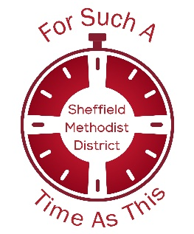
Eclipse Party: evaluation
Eclipse Party grants are awarded conditional on completing evaluations. Please return this form to Katrin Hackett, District Administrator admin@sheffieldmethodist.org by 15 October.
The purpose of this evaluation is twofold:
- to help you explore what you have learned and what this means next for you in your specific context
- to help your district understand how it can best support you and others in the future
Trying new things usually involves “learning on the job”, risk taking and responding to the needs of the specific people God has brought us to. Some experiments work in the way we had imagined, others inevitably do not but we learn something valuable from them. Both have value. Please be as open as possible in your reflections and allow yourself time to discuss them with your team, your church leadership and, where relevant, people who have participated in your event.
Individual evaluations will be collated into an overall review. This will not include any information which identifies any specific church without first checking with you.
Church/ circuit
Person completing this evaluation
Team/ group/ other people who have had sight of this evaluation

What was the best/ most significant thing about your eclipse party
How did people in your congregation feel about talking about faith during the event? Would they feel more natural doing this in the future?
What have you learned about your church from hosting your eclipse party?
Might you host future outreach events linked to significant cultural events or occasions? What support or resources would be helpful, compared to that offered for the eclipse?

STATISTICAL QUESTIONS – these will be collated are to help us understand the cumulative impact of the Eclipse Parties across our district. Larger does not necessarily mean better. They will not be published individually or used to pass judgement on churches.
We are seeking your broad sense from conversation, not asking for you to collect intrusive survey data.
Approximately how many people were present at your eclipse party who at the time were
already part of your congregation?
members of another church?
not part of any congregation but already had some connection with your church?
not part of any congregation and not connected with your church?

STORY TO SHARE PUBLICLY
Please also share with us some pictures (with consent of people featured in them)
A paragraph or quote that captured something significant from your event, for example feedback from someone who attended, or a quote from a member of your congregation who spoke about their faith during a conversation in a new way.

