DISTRICT LEADING TEAM MEMBERSHIP
The District Leading Team (“DLT”) exists to serve, guide and co-ordinate the life of the district. Its members are the legal and managing trustees of the district.
Membership of the District Leading Team comprises:
- Members mandated by Methodist Standing Orders
  - Chair of district
  - Synod secretary
  - Representative to Methodist Council
- Other ex-officio members
  - Treasurer
  - Deputy chair of district
- Up to six other members bringing relevant skills and experience
Members of DLT are chosen to meet individually and collectively the person specification below.

HOW WE WORK
DLT usually meets six times each year for regular meetings, plus two additional half day gatherings focussed on shaping longer term visions and plans.
Whilst we have a strong staff team and broad base of district officers, members of DLT are expected to play some role in implementing decisions between meetings. In this we recognise that different people have different calls on their time and different expertise, so level of involvement between meetings is flexible.
We meet on weekday evenings (usually on Zoom), and hold half day meetings at weekends, to be as accessible as possible to lay people.
We circulate our agendas, papers and minutes to superintendents as a matter of routine, to keep DLT connected to the life of our circuits. Where people beyond DLT have specific contributions to a particular discussion, we invite them to attend all or relevant part of our meetings.
DLT members are required to have completed Advanced Safeguarding training, or complete this as soon as practical after starting in post.

WHAT WE ARE RESPONSIBLE FOR
Regular meetings focus in turn on one of the six For Such A Time As This strategic themes as the biggest part of our agenda, so that each is addressed in detail each year.
Other recurring responsibilities include:
- Awarding of missional property and employment grants
- Oversight of district finances
- Responding to requests concerning significant events in the life of our district (e.g. opening/ closing of churches, significant property redevelopments, permission for lay members to preside at holy communion)
- Approval of changes to district staff team
- Co-ordination of the work of district panels, discretionary groups, working parties and officers
We aim for district governance which is:
- Lean – reducing time spent on routine matters and removing duplication of effort
- Robust – with a diversity of voices and strong expertise integrated into decision-making
- Focussed on implementing for such a time as this
- Dynamic – responsive to changing circumstances

HOW THE DISTRICT OPERATES
Much of the work of the district is led by a broad base of voluntary officers, panels that CPD requires to carry out essential functions, other groups we have established to oversee important pieces of work, and gatherings where perspectives and wisdom are shared. And by our staff team.
Given the broad scope of our responsibilities this inevitably looks complex in the diagram below. The role of DLT is to hold strategic oversight of our work, rather than to be involved in the detail of all of it.
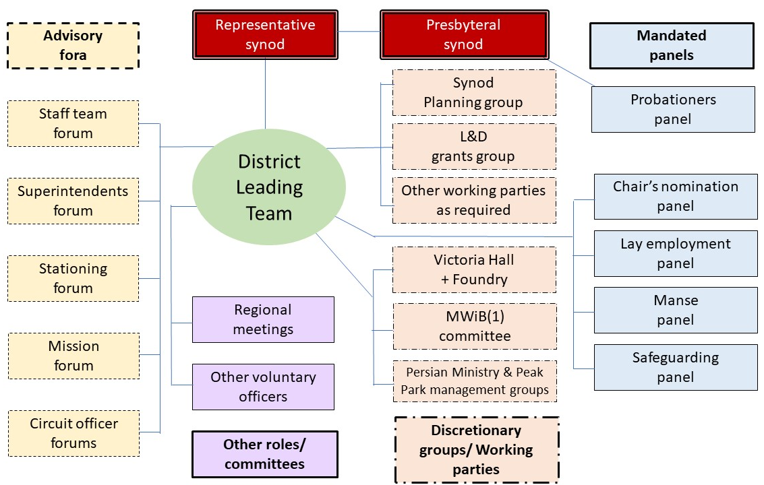
- Methodist Women In Britain

SKILLS WE NEED
To function effectively we need all members of DLT to be:
- Excited by the opportunities before us in For Such A Time As This and committed to promoting its implementation
- Willing to offer and hear dissenting opinions during discussion, but to embrace collective decisions
- Able to work as a geographically dispersed team
- Able to hold confidence and manage conflicts of interest within a Connexional church
- Happy to be a face of district leadership in their contexts
- Committed to enabling and inspiring missional change through the many people of our membership – learning, changing, and joining in

Between us we will benefit from possessing the following abilities, knowledge, skills and aptitudes. Not everyone will bring all of these, but if some of them sound like you please mention on your expression of interest.
Proven abilities:
- Leading and managing change
- Identifying and pursuing continuous improvements
- Practical experience of evangelism in contemporary culture
- Maintaining oversight of strategic or operational changes and their implementation
- Intentionally leading growth in depth and numbers of disciples
- Promoting and sharing best practice in leading of contextual worship
Knowledge & skills:
- Using detailed understanding of Methodist CPD as a permissive document
- Expertise in discipleship and missional models
- Knowledge of current Connexional priorities and strategies
- Understanding of digital culture and its implications for discipleship, worship and mission
Qualities and aptitudes:
- Advocacy for the importance of evangelism
- Creative pioneering spirit able to challenge conventional thinking
- Ability to think theologically with regard to property and finance
- Ability to weigh up alternative options and make strategic choices
- Range of group dynamics roles
- Diversity of theological perspectives, lived experiences, ordained/ employed/ lay ministries within the life of our churches, networks and geographical locations

