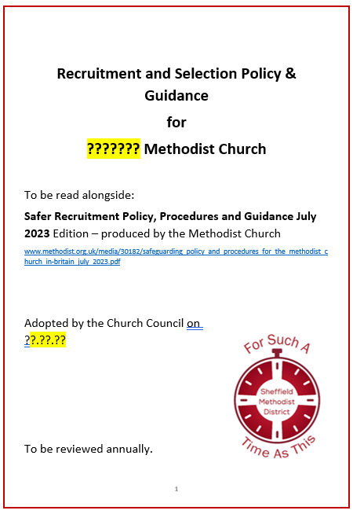

Church Safeguarding Officers Guide to the local Recruitment and Selection Policy & Guidance Feb 2022

Front page:
The bits highlighted in yellow will need editing with your church’s specific details.

This District created model policy and guidance does not replace the Connexional Policy but rather adds a local level of understanding. The two should always be considered together.

- Introduction
- Responsibilities for Safer recruitment in the Methodist Church
(Pg 2)

I’ve simply cut and pasted from the Connexional safer Recruitment policy.

The 12 steps to Safer Recruitment (pg 3)
There are 2 types of recruitment processes that normally take place in a church:
- Employing a Lay Worker
- Recruiting a volunteer

If you are employing someone the 12 steps still apply but there is a District officer, Andrew Crawford, who will provide formal help and assistance to fulfil legal requirements. The Connexional policy will also provide more help and information.
Most churches will be more concerned with recruiting volunteers which is much less formal but just as important. This local, model policy is designed to help group leaders recruit volunteers.

Additional Guidance (Pg 4)
DBS Checks
If you use the template I have provided them, as Church Safeguarding Officers, you will need to add in the level of Safeguarding Training the role will require and whether the role requires a DBS check. If the role does require a DBS check I suggest you add in the most appropriate Job Role.
The person completing the DBS check will be given a list of options. If you can tell them which job title is most appropriate it will save them time and reduce the risk of the wrong check being carried out.
These are the job roles available for volunteers, some are easy to identify:
Charity Trustee
Church Administrator
Church Bus Driver Volunteer
Church Bus Driver volunteer (Regulated Activity)
Church or Circuit Safeguarding Officer (Volunteer Reg Activity)
Church or Circuit Safeguarding Officer (Volunteer)
Local Preacher or Worship Leader
Local Preacher or Worship Leader (Regulated Activity)
Premises Worker or Caretaker specified place (vol)

Some are not so easy to work out:
Child and YP (non-regulated) and Adult (Regulated) volunteer
Child and YP (Regulated) and Adult (Non-regulated) volunteer
Children Young People Church Volunteer
Children Young People Church Volunteer (Regulated Activity)
Children Young People Vulnerable Adults Vol (Reg Activity)
Children Young People Vulnerable Adults Volunteer
Vulnerable Adults Volunteer
Vulnerable Adults volunteer (Regulated Activity)

The following information will help you work out which job is the right one.
Regulated Activity
What is Regulated Activity?
In a nutshell, Regulated Activity is work that a barred person must not do. It is the term used to describe certain functions that are carried out by an individual as part of their role that would require them to have an Enhanced DBS Check with a check against the relevant barred lists.
The barred list(s) check they would need would differ depending on whether the individual is working with children, vulnerable adults or both.
How do I know if somebody is carrying out Regulated Activity with Children?
To establish whether or not an individual is engaging in Regulated Activity with Children, you have to take into consideration two factors;
- The role – Unsupervised teaching, training, instruction, care or supervision of children.
- The setting – If they are not performing one of the roles above, they may be carrying out an ancillary role within a specified setting. This includes positions such as a Cleaner in a School or Admin staff in a Nursery. Other specified settings include Children’s Detention Centres, Children’s Homes and Childcare Premises.
If they meet the criteria above, they will be eligible for an Enhanced DBS Check with a Child’s Barred List check if they:
- Are performing this role more than 3 times in a 30-day period
- Could have contact with children within the establishment
- Work there for the purpose of the establishment
- Are not employed on a temporary basis
- Are not in a supervised volunteer role
How do I know if somebody is carrying out Regulated Activity with Adults?
Unlike Regulated Activity with Children, Regulated Activity with Adults focuses on the specific activities that are provided to an adult that requires them, rather than the setting in which a specific activity is taking place.
For example, any individual that provides personal care to an adult will be engaging in Regulated Activity irrespective of whether that occurs in a hospital, a care home, a prison or in sheltered housing.
There are SIX categories that define Regulated Activity with Adults:
- Providing Health Care to an adult including palliative care, psychotherapy, and counselling
- Providing Personal Care to an adult in the form of feeding, washing or toileting etc.
- Providing Social Work to an adult in connection with health services or social services
- Conveying an adult to or from Health Care, Personal Care, or Social Work appointments
- Assisting an adult in the conduct of their own affairs under a formal appointment
- Assisting an adult with general household matters such as managing cash, paying bills or shopping on their behalf.
For both RA with Adults and RA with Children, any activity that is carried out in the course of family relationships and personal, non-commercial relationships is not classed as Regulated Activity.
Pages 18 & 19 in the Connexional Safer recruitment policy provides examples of church roles that may or may not require an enhanced DBS.
The table on the following page also suggests a list of roles which are described as Regulated.
If you are in any doubt always air on the side of caution and go for a higher-level check.
Safeguarding Training
When it comes to deciding who needs to complete which module of safeguarding training things become simpler.
Please see the Safeguarding Polices, Procedures and Guidance 2021 pages 143 to 146 for full details: https://www.methodist.org.uk/media/24067/safeguarding_policy_procedures_and-_guidance_for_the_methodist_church_oct_2021docx.pdf
Safeguarding Training Attendance List: Foundation 2020 Edition
Core List (church level) – Required Attendance
- lay employees and volunteer workers with pastoral responsibility
- pastoral visitors
- anyone working with children in the name of the church
- anyone working in activities targeted at adults who are vulnerable (e.g. luncheon club for the housebound)
- church stewards
- church safeguarding representatives
- choir/music group/drama leaders – where there are children or vulnerable adults in the group.
- young Leaders (ages 16-18)

Warmly invited but not mandatory
- evangelism/mission enablers
- […] leaders of other groups or organisations that regularly hire or use Methodist premises for work with children and vulnerable adults but do not have access to safeguarding training elsewhere and do not have their own safeguarding policy.
- remaining Choir/music group/drama leaders
- any other group leaders within the church, who may have adults who are vulnerable within their group.
- property stewards and other keyholders
- caretakers
- church/circuit meeting secretaries
- church/circuit/district administrators

Advanced Module 2019 Edition (Formerly Leadership Module)
Core List (church level) – Required Attendance
- safeguarding officer - Church
- those who are in paid employment or a voluntary role which includes leadership within the Methodist Church, involving direct work with children, young people or vulnerable adults
- those in recognised roles involving pioneering, fresh expressions or evangelism
- mentors for the Youth Participation Scheme

Step 5: Information Pack

It is the Church Safeguarding Officers responsibility to make copies and keep any and all Safeguarding Form relating to Safer Recruitment.

Therefore, by asking Group Leaders to speak to you for advice on which forms are required you will better understand which groups are running in your church and who should be passing over the paperwork for safe storage and retention.

These are the forms used in safeguarding. The first 3 apply to any role and then you have some forms that will only be needed for specific roles:

Mandatory
Church Safeguarding Policy | Specific to your church
Role Outline (step 3) | Specific to your church and role
Safeguarding Declaration | There are 4 Declarations Forms to choose from.  The Connexional Policy provides clear information about the 4 options on pages 11 & 12  You can also access the information and forms straight from the Methodist Church website or by going to:  https://www.methodist.org.uk/safeguarding/safer-recruitment-including-dbspvg-ddc-forms-policy-and-guidance-documents/forms/confidential-safeguarding-declarations/  Please note SD/3 Safeguarding self-declaration for Methodist Council members is only used at Connexional Level.

Optional depending on the role
Volunteer with Vulnerable Groups –  Form A | Form A Part 1 & 2 should be completed by all parties volunteering to work with children, young people and vulnerable adults.  The forms can be found on the Methodist Church website or by going to:  https://www.methodist.org.uk/safeguarding/safer-recruitment-including-dbspvg-ddc-forms-policy-and-guidance-documents/forms/volunteer-with-vulnerable-groups-form-a/  - Form A Part 1 is the Registration Form with the Privacy Notice  - Form A Part 2 is the Volunteer agreement which includes the role outline.
Key Holder Declaration – Form D | The Methodist Church is not obliged to give anyone access to church premises unless access to the premises is required as part of their role. Before the keys can be issued the key holder is asked to sign the declaration and acknowledge the conditions of issue.  The form can be found here or by going to:  https://www.methodist.org.uk/safeguarding/safer-recruitment-including-dbspvg-ddc-forms-policy-and-guidance-documents/forms/key-holder-declaration-form-d/  If you someone has a key then they may access the building on their own so there should be a discussion around Lone Working.  The Methodist Church recognise that a number of lay employees may work alone and so the Lay Employees Stakeholders Group has produced some guidance to assist employers and lay employees in how best to assess the risks; manage lone working arrangements and fulfil their responsibilities to work safely.  These guidelines should be discussed locally so that appropriate arrangements are put in place and then reviewed on a regular basis.  The guidance can be accessed by clicking here or by going to:  https://www.methodist.org.uk/for-churches/employees-and-volunteers/lay-employment-resource/8-key-policies-and-guidance-documents/lone-working/downloadable-templates-lone-working-risk-assessment-and-guidelines/  On page 12 of this guide you will find a simplified version of a Lone Worker Policy if that would be more appropriate. Please edit it to reflect the individual nature of your church.

Step 7 – Appropriate Checks
In step 7, I suggest group leaders should liaise with the Church Safeguarding Officer regarding training.
We have already covered training on pages 6 & 7 of this document.
Part of the role of the Church Safeguarding Officer is to:
• identify and inform those who are required to attend safeguarding training and maintain records of attendance.
When a group leader comes to you to check about training is would be advisable to make a note of the following so you know who to contact in the future:
- Role
- Group
- Group Leader
Step 12 – Next Steps
This is the time when a DBS check needs completing if a volunteer role requires one. The local church policy, on page 7, needs editing with the names of people who could do the checks for your church.
Some churches will have the ability to carry out checks themselves and some will need to rely on people who have access to the circuit account.
The following people currently have permission to complete checks in the Trinity circuit:
PLEASE CONTACT ALISON HILL FOR AN UP TO DATE LIST FOR YOUR CIRCUIT
You can leave the group leader to liaise with someone about the DBS check but once the volunteer has received their certificate you will need to record the Date of Issue so you will be able to prompt group leaders in 5 years’ time when the check will need reviewing.
The circuit will receive a confirmation email with the date of issue on. If you are able to get a copy of this email then you won’t need to ask the volunteer to show you their certificate.
If you have a large number of volunteers and DBS checks are done through a circuit account I advise you to speak to your Superintendent who can advice and guide you further.

As always if you are having any issues or need help or guidance please email me and I will get back to you.
Thank you for the important part you play In Safer Recruitment.
Alison Hill
Sheffield District Safeguarding Officer

Lone Working Policy for Volunteers
…………………………….. Methodist Church is committed to providing a safe environment for volunteers. This policy lays out the responsibilities with regard to working alone in the building or grounds. The risk assessment is to be reviewed annually or more frequently if there is any incident involving someone working alone.
Introduction
At times, many church volunteers will be in situations where they are a 'lone worker'. The recommendations below try to be realistic about what can and cannot be put in place. Whilst it must be recognised that the Church does not have the structure associated with a large business, its aims to be a good employer, concerned about the safety of employees including volunteers.
Under the Health and Safety at Work Act 1974 and the Management of Health and Safety at Work Regulations 1999, the employer has a duty of care to advise and assess risk for workers when they work by themselves in these circumstances. However, employees and volunteers have responsibilities to take reasonable care of themselves and other people affected by their work.
Aims of the Policy
The aim of the policy is to:
- Increase volunteer’s awareness of safety issues relating to lone working.
- Ensure that the risk of lone working is assessed in a systematic and ongoing way, and that safe systems and methods of work are put in place to reduce the risk so far as is reasonably practicable.
- Ensure that appropriate support is available to volunteers that equips them to recognise risk and provides practical advice on safety when working alone.
- Encourage full reporting and recording of all adverse incidents relating to lone working.
- Reduce the number of incidents and injuries to volunteers related to lone working.
Church council’s responsibilities
- Identify staff and volunteers who are lone workers.
- Inform staff and volunteers of their responsibilities under the Lone Working Policy.
- Ensure all new staff and volunteers are aware of Lone Working protocols.
- Ensure that a risk assessment has been completed and documented and is regularly reviewed. A formal Risk Assessment is needed for lay workers and Presbyters.
- Put procedures in place which are designed to eliminate or reduce the risks associated with Lone Working
- Define limits of what cannot be done while working alone
- Ensure that staff and volunteers identified as being at risk are given appropriate information, instruction and training.
Staff and Volunteer Responsibilities
- It is the responsibility of all volunteers to take care of themselves.
- They should never knowingly put themselves at risk.
- Ensure they read, understand and comply with the Lone Working policy.
- Participate in the risk assessment process to reduce the risk associated with lone working. Any incidents should be recorded in the accident book kept in the office.

Good Practice for Lone Workers
- All employees and volunteers leaving the workplace (or home) to undertake work-related tasks alone should consider leaving details of where they are going and their estimated time of arrival back at base.
- When arranging one-to-one meetings, employees and volunteers should consider whether contact could take place in an environment where confidentiality could be maintained but others would be in the vicinity.
- Lone workers should have access to adequate first-aid facilities.
- Lone workers should be provided with a mobile phone and other personal safety equipment where this is necessary.

Risk Assessments
The current risk assessment follows, and forms part of this policy.
For reviewing the lone working risk assessment, the following questions will be considered:
- Is it necessary for the individual to work alone?
- Does the workplace or task present a special risk to the lone worker?
- Is there a safe means of entry and exit?
- Is there any cash or valuables on the premises?
- Do lone workers have knowledge of the hazards and risks to which they are possibly being exposed?
- Do lone workers know what to do if something goes wrong?
- Does someone else know the whereabouts of the lone workers and what they are doing?
- Are there adequate channels of communication in an emergency?
- Is the person medically fit and suitable to work alone?
- Is there a risk of violence?
- Are women especially at risk if they work alone?
- Is any known risk attached to a home visit?
- Has an alternative to a home visit been considered?
- Has safe travelling between appointments been arranged?
- Have reporting and recording arrangements been made where appropriate?

Lone Working Risk Assessment
Use this to assess your environment, and your working practices, as well as for an instant assessment of a situation.
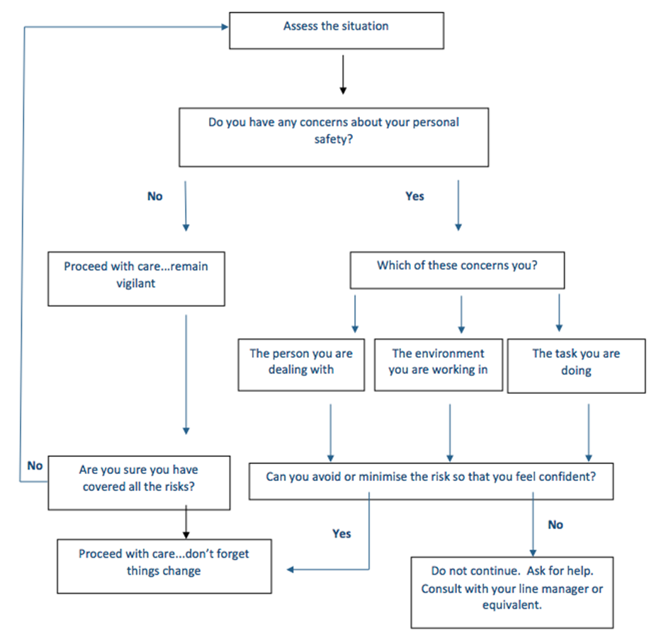

From Personal Safety at Work, Suzy Lamplugh Trust 2006, revised 2008

