Working with Adults
- A safeguarding guide for group leaders and volunteers

Contents:
Code of Safer Working practice with Adults Page 3
- Promoting Safer Practice
- Appropriate Conduct

Additional guidelines for group leaders who work with adults Page 4
- Activity risk assessments

Definitions of Key Terms when Safeguarding Adults Page 5
- Safeguarding definitions
- Abuse Definitions
- Possible indicators of abuse in adults

The Care Act (2014) and Statutory Guidance Page 11
- Guidance on capacity

Introduction
This booklet brings together various guidance documents aimed at people providing activities for adults.
All the information can be found in the Safeguarding Policy, Procedures and Guidance for the Methodist Church in Britain (June 2023)

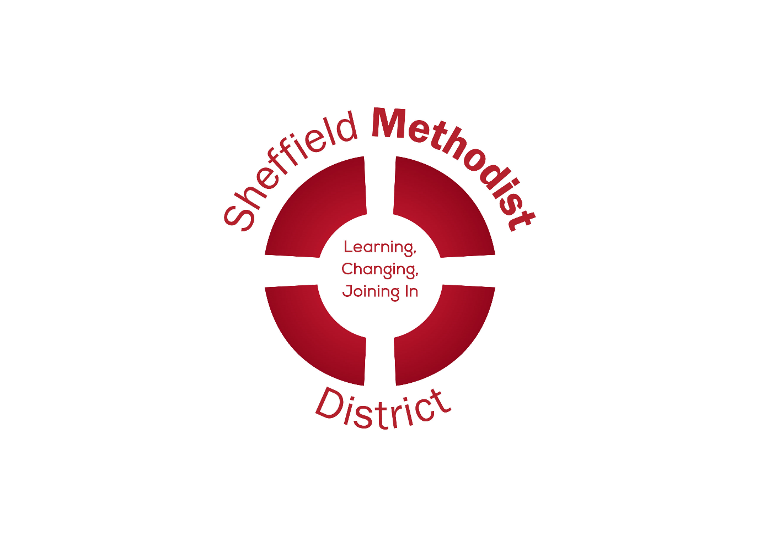

Code of Safer Working Practice with Adults
Promoting Safer Practice
Safer working practices is critical to good safeguarding. The Church has developed procedures informed by legislation and government guidance. As such, we aim to:
- carefully select and train all those with responsibility within the Church in line with safer recruitment principles
- ensure that any church activities are organised in such a way to avoid the risk of harm to everyone participating
- promote safe spaces that are inclusive and welcoming.

Appropriate conduct
You should:
- treat all adults with respect and dignity
- ensure that your own language, tone of voice, and body language are respectful
- record any incidents of concern and give the information to your group leader, sign and date the record
- share concerns about an adult or the behaviour of another worker with your group leader and/or safeguarding officer.
You should not:
- invade the privacy of an adult who is washing and toileting
- use any form of physical punishment or restraint (apart from car seat belts)
- be sexually suggestive about or to an adult, or scapegoat, ridicule or reject an adult or group
- permit abusive peer activities (e.g. initiation ceremonies, ridiculing or bullying)
- show favouritism to any one adult or group
- allow an adult to involve you in behaviour that is overtly physical or sexual
- allow unknown adults access to adults deemed at risk of harm (visitors should always be accompanied by a known person)
- allow strangers to give lifts to adults in your group.

Visiting adults at home
- Most visits to adults in their own home will be straightforward as they will be well known to the church. However, when visiting someone new for the first time, visitors should let someone else know whom they are visiting (and when).
- Visiting in twos may be advisable, especially if the adult lacks capacity. It is also advisable to take a mobile phone.
- Do not call unannounced. Call by appointment, telephoning the person just before visiting if appropriate.
- Be clear about what support can be offered to the adult if they ask for help with particular problems and refer back to the church if uncertain.
- Do not make referrals to any agency that could provide help without the adult’s permission, and ideally encourage them to set up the contact.
- Never offer ‘over the counter’ remedies to people on visits or administer prescribed medicines, even if asked to do so.
- Do not accept any gifts from adults other than token items, to avoid misunderstandings or subsequent accusations from the person or their family. If someone wants to make a donation to the church, put it in an envelope, mark it on the outside as a donation and obtain a receipt from the treasurer.
- Pastoral visitors should note the date when they visit people, report their visit to the pastoral secretary and say what is concerning or going well. The pastoral secretary will report safeguarding concerns to the minister and safeguarding officer as appropriate and agree what action should take place and who should record the incident.

Additional guidelines for group leaders who work with adults
The provision of a service whether that is small or large or involving paid employees or volunteers, the provider must take reasonable steps to ensure the safety of those using the service. At the very least, the group leader should:
- ensure that health and safety requirements are understood and adhered to (e.g. the suitability of the setting for the activity planned, where the first aid kit is and who are the trained first-aiders, where the fire exits are)
- undertake risk assessments, take appropriate action, and record it
- keep the register (where required) and consent forms up to date (including emergency contact details for participants)
- liaise with safeguarding officer over good practice for safeguarding
- inform the safeguarding officer of any specific safeguarding concerns that arise (the safeguarding officer will liaise with the DSO)
- liaise with the Church Council/Circuit Meeting
- ensure that relevant privacy notices have been supplied where data is being processed.
Activity risk assessments
While the Church recognises that it is not possible to avoid all risk when working with vulnerable groups, it is possible to try and minimise those risks. This can be achieved through careful planning and preparation and by providing a written record of the thought processes and action taken. Activity risk assessments should be undertaken before any activity takes place, approved by the event leader/minister and retained securely in case they need to be seen at a later date (e.g. as a result of an accident taking place).
- Activity risk assessments should include, but is not limited to:
- the nature of the activity
- the location
- transport needed and associated issues (e.g. insurance)
- staffing levels/gender
- experience of staff ▪ages of the group attending, abilities, special needs
- medical and health needs of the group/individuals within it
- emergency planning
- identified risks ▪action(s) needed to address the risk and by whom.

Definitions of Key Terms when Safeguarding Adults
Adult safeguarding is working with adults with care and support needs to keep them safe from abuse or neglect. It is aimed at people with care and support needs who may be in vulnerable circumstances and at risk of abuse or neglect.
Safeguarding definitions
The Care Act 2014 states that safeguarding duties apply to an adult, aged 18 years or over, who:
- has needs for care and support (whether or not the local authority is meeting any of those needs)
- is experiencing or at risk of abuse or neglect
- as a result of those care and support needs is unable to protect themselves from either the risk of or the experience of abuse or neglect.
While the term “vulnerable adult” is not used in the statutory sector since the introduction of the Care Act 2014, the Methodist Church continues to use the term in recognition that any person can be vulnerable and therefore in need of support at any time. In Scotland, a Protected Adult is an individual aged 16 or above who is receiving certain types of services. There are four categories of services specified in the Protection of Vulnerable Groups Act (PVG Act): A support service; a care home service; a housing support service; and/or, an adult placement service.
In order to bring into focus those adults for whom the Church should have a particular care, the Methodist Church has adopted the definition used by Thirtyone:Eight :
Any adult aged 18 or over who, due to disability, mental function, age or illness or traumatic circumstances, may not be able to take care or protect themselves against the risk of significant harm, abuse, bullying, harassment, mistreatment or exploitation.
Although everyone is vulnerable in some way and at certain times, some people by reason of their physical or social circumstances have higher levels of vulnerability than others. Some of the factors which increase vulnerability are:
- a sensory or physical disability or impairment or a learning disability
- a physical illness
- mental ill health (including dementia), chronic or acute
- addiction to alcohol or drugs
- failing faculties in old age
- a permanent or temporary reduction in physical, mental or emotional capacity brought about by life events, for example bereavement or previous abuse or trauma.
It is important to remember that:
- vulnerability is often not a permanent state
- vulnerability is not always visible
- a person with apparently visible vulnerabilities may not perceive themselves as such
- anyone can be vulnerable at different stages of life
- vulnerable people may also pose risk and cause harm.
Refugees and asylum seekers will meet this definition of vulnerability by virtue of their circumstances.

Abuse definitions
Physical abuse
The non-accidental infliction of physical force, which results in pain, injury or impairment. This may include hitting, assault, slapping, pushing, pinching, kicking, hair-pulling, punching, forcing someone, inappropriate restraint, physical sanction, incorrect moving or handling technique which cause distress, isolation, confinement, avoidable deterioration of health, misuse of prescribed medication. Care and Support Statutory Guidance, Issued under the Care Act 2014 (Department of Health)
Sexual abuse
The involvement of an adult with care and support needs in sexual activities or relationships without informed or valid consent. This may involve offensive or inappropriate language (including sexual innuendo and sexual teasing), inappropriate looking, inflicting pornography on an individual, inappropriate touching, masturbation in public, indecent exposure, coercion into an activity, rape or sexual assault, photography, online and social media abuse.
Psychological/emotional abuse Behaviour that has a harmful effect on an adult’s emotional health or development. This can include:
- scolding or treating like a child;
- making a person feel ashamed of involuntary behaviour;
- blaming someone for attitudes or actions or events beyond their control;
- use of silence, humiliation, bullying, harassment and verbal abuse intimidation;
- controlling behaviour or efforts to create overdependence;
- lack of privacy or dignity; ▪deprivation of social contact;
- threats to withdraw help and support;
- denial of cultural and spiritual needs; and,
- denial of choice or failing to respond to emotional needs.
Financial / Material abuse
The denial of access of the individual to money, property, possessions, valuables or inheritance, or improper use of funds by omission, exploitation or extortion through threats. Although financial abuse can occur in isolation, where other forms of abuse occur, financial abuse is also likely. Care and Support Statutory Guidance, Issued under the Care Act 2014 (Department of Health) This includes misuse, embezzlement or theft, or misappropriation of a person’s money, property, possessions or benefits. Also, refusing a person access to their own money, property or possessions, failing to account properly for money, property or possessions or applying pressure in connection to wills, property and inheritance, or applying duress to a person in order to secure a loan.
Neglect and acts of omission
The repeated withholding of adequate care which results in the adult’s basic needs not being met. It can be intentional or unintentional and includes acts of omission. This may include denial of educational, social, religious, cultural or recreational needs, lack of adequate heating, lighting, food or fluids. Also the inappropriate use of medication, lack of attention to hygiene, toe and fingernails or teeth.
Self-neglect
Self-neglect refers to omitting to care for one’s personal hygiene, health or environment. For examples:
- Not meeting basic needs, including personal hygiene and appropriate clothing.
- Neglecting to seek help for medical matters.
- Not attending to living conditions – letting rubbish accumulate in the garden, or dirt to accumulate in the house.
- Hoarding items or animals.
Action to address neglect in adulthood has to be balanced with an individual’s wish to make decisions for themselves (Liberty Protection Safeguards).
Discriminatory abuse
This occurs when values, beliefs or culture result in the misuse of power that denies opportunities to some individuals or groups based on the nine protected characteristics listed on the Equality Act 2010.
Additional areas of abuse identified and recognised by the Methodist Church include:
Institutional abuse
This includes neglect and poor practice within an institution or specific care setting such as a hospital or care home, or in relation to care provided in one’s home. This may range from one-off incidents to ongoing ill treatment. It can be through neglect or poor professional practice or a result of the structure, policies, processes and practices within an organisation. Care and Support Statutory Guidance, Issued under the Care Act 2014 (Department of Health)
Spiritual abuse
Coercion and control of one individual by another in a spiritual context. The target experiences spiritual abuse as a deeply personal attack. This abuse may include manipulation and exploitation, enforced accountability, censorship of decision-making, requirements for secrecy and silence, pressure to conform, misuse of Scripture or the pulpit to control behaviour, requirement of obedience to the abuser, the suggestion that the abuser has a ‘divine’ position, isolation from others, especially those external to the abusive context’. Oakley and Kinmond (2014) Journal of Adult Protection 16.2
Human trafficking
Human trafficking is described as ‘the process of trapping people through the use of violence, deception or coercion and exploiting them for financial or personal gain’ (What is human trafficking? - Anti-Slavery International (antislavery.org). People who are trafficked are usually vulnerable because of the risks they are willing to take to escape poverty, discrimination and/or persecution.
Modern slavery
Modern slavery is the severe exploitation of usually vulnerable people for financial or personal gain. It is a relationship that sees a person or persons coerced into providing labour or a service for no financial or other form of recompense resulting in economic exploitation.
Abuse using social media and/or mobile phones
Includes communications that seek to intimidate, control, manipulate, put down, falsely discredit or humiliate the recipient. It may also include threatening a person’s earnings, employment, reputation or safety, and sexting.

Possible indicators of abuse in adults
This is not a definitive list of indicators but rather some examples of what may be observed. Some indicators occur across the categories and not all categories are covered here. In some of the examples below the action is a clear form of abuse:
Physical
- a history of unexplained falls
- injuries inconsistent with the lifestyle
- dehydration and/or malnutrition
- poor skin condition or poor skin hygiene
- loss of weight
- broken spectacles/frames
- a vulnerable person telling you they have been hit, slapped, kicked or mistreated ▪varicose ulcers or pressure sores without illness-related cause
- unexplained bruises or untreated restrained injuries in various stages of healing
- unexplained burns, rope burns or cigarette burns
- injuries reflecting the shape of an object
- physical indicators of being subjected to punishment
Emotional
- an adult being scolded or blamed for actions beyond their control
- making a person feel ashamed of involuntary behaviour
- Infantilisation or treated like a child
- controlling or over-dependence
- Humiliation
- denying of choice
- verbal abuse
- bullying/harassment
- controlling or over-dependence
- threats to withdraw help and support
- lack of privacy and dignity
- denying of cultural and spiritual needs
Neglect
- clothing which is inadequate or in poor condition
- evidence of sores, varicose ulcers, pressure sores
- an untreated medical condition
- weight loss
- poor hygiene and cleanliness
- poor physical condition e.g. rashes, unclean
- verbal abuse
- bullying/harassment
- health and safety hazards in the environment
- persistent hunger and/or dehydrationPage
Self-neglect
- dehydration, malnutrition (or obesity), untreated medical conditions, poor personal hygiene
- hazardous living conditions e.g. improper wiring, no indoor plumbing, no heat or running water
- unsanitary living quarters e.g. animal/insect infestation, no functioning toilet, excrement present
- inappropriate and/or inadequate clothing, lack of necessary medical aids e.g. glasses, hearing aids, dentures
- grossly inadequate housing or homelessness
Sexual abuse
- a significant change in sexual behaviour or sexually implicit/explicit behaviour
- a vulnerable person telling you they have been sexually assaulted or raped.
- an untreated medical condition
- weight loss
- poor hygiene and cleanliness
- persistent hunger and/or dehydration
- verbal abuse
- bullying/harassment
- health and safety hazards in the environment
- poor physical condition e.g. rashes, unclean
Institutional abuse
- lack of flexibility or choice
- inadequate staffing levels
- a culture of treating everyone using the service as ‘the same’ opposed to ‘equal’
- failure to promote or support a person’s spiritual or cultural beliefs
- inappropriate or poor care
- dehumanising language
- no opportunity for snacks or drinks
- absence of individual care
Spiritual abuse
- a sense of betrayal leading to distrust
- silencing by their abuser and powerlessness
- feeling misunderstood and self-isolation
- loss of church as safe space
- change / damaged view of the Church
- long-term distress
Domestic abuse
- frequent absences from work or other commitments
- wears clothes that conceal bruises even on warm days
- unexplained bruises or injuries
- stops talking about partner
- panic attacks
- always accompanied by partner
- anxious about being out or rushes away
- isolated, withdrawing from friends and family
Human trafficking and modern slavery
- Trauma
- Appears to be in a dependency situation
- Seems to be bonded by a debt
- Anger and post-traumatic altruism
- Complex medical, emotional, mental and practical needs
- Experiences threats against themselves or family members
- Previous history of being trafficked
- Expressing of anxiety, fear or mistrust
- Unable to negotiate working conditions or leave their employment
- Travel, identity, financial documents are held by someone else
- May look malnourished, lacking access to medical care, hygiene facilities and education
- On low pay or have excessive deductions made for food, accommodation, transport
- Apparent high resilience masking trauma
- Unsure of home/work address
- May appear unfamiliar with their neighbourhood
- May appear unkempt or wear same clothes day in and day out
- Reluctant to seek help or to trust others
- Untreated injuries or medical conditions

The Care Act (2014) and Statutory Guidance
Legislation defines the aims of adult safeguarding as:
- prevent harm and reduce the risk of abuse and neglect to adults with care and support needs
- safeguard adults in a way that supports them in making choices and having control about how they want to live
- promote and approach that improves life for the adult concerned
- stops abuse and neglect where possible through prevention, identification and response.
- provides information and support in an accessible manner so that people understand different forms of abuse.
The Care Act identifies gives six key principles that underpin all adult safeguarding work:
Empowerment - People being supported and encouraged to make their own decisions and informed consent Prevention - It is better to take action before harm occurs
Proportionality - The least intrusive response appropriate to the risk presented
Protection - Support and representation for those in greatest need
Partnership - Local solutions through services working with the communities. Communities have a part to play in preventing, detecting and reporting neglect and abuse
Accountability - Transparency in delivering safeguarding
Guidance on capacity
The concept of capacity is important and must be applied in certain contexts to assess whether an individual is able to make a specific decision at a particular time. By law, all adults are presumed to have capacity to make decisions about themselves unless an assessment illustrates otherwise. Those who work with them should make every reasonable endeavour to obtain the decision from the adult. It is best to seek guidance from Adult Social Care services about defining a person’s mental capacity if there is concern about their ability to understand safeguarding processes.

