Risk Assessments for Church led Activities

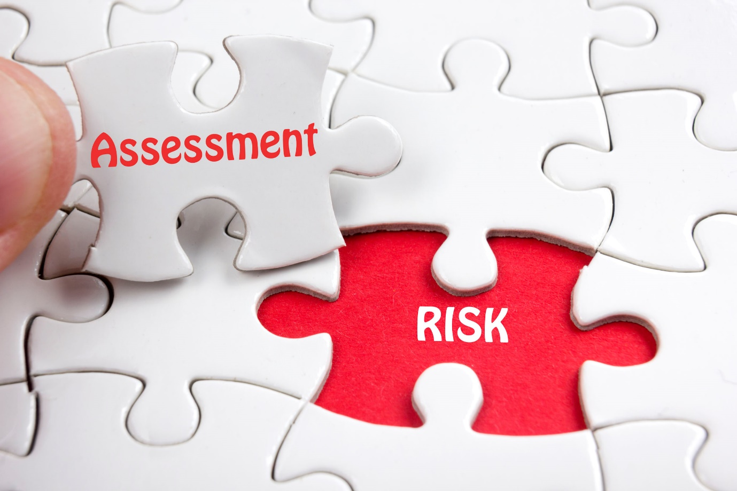

Activity risk assessments will be undertaken before any activity takes place to minimise the risk of harm to those involved. Approval will be obtained from the event leader/minister. A written record of the assessment will be retained securely.
Model Church Safeguarding Policy July 2023

Risk Assessments for Church lead Activities
Introduction
In the model Church Safeguarding Policy (2023), under Good Practise, the following point is made:
Activity risk assessments will be undertaken before any activity takes place to minimise the risk of harm to those involved. Approval will be obtained from the event leader/minister. A written record of the assessment will be retained securely.
Further into the policy specific expectations are stated in regards to ‘Events with church groups off the premises’:
Adequate staffing, a risk assessment and notification of the event will be given to the church safeguarding officer PRIOR to the agreement for any event or off site activity. Notification of the event will be given to the church council secretary:……………………(name of church council secretary).
If the activity is unusual or considered to be high risk the church safeguarding officer will contact the circuit safeguarding officer in order that it can be ratified or any queries raised.

What to include in an Activity Risk Assessment?
Taken from Safeguarding Policy, procedures and Guidance for the Methodist Church, July 2023 (SPP & G, July23):
While the Church recognises that it is not possible to avoid all risk when working with vulnerable groups, it is possible to try and minimise those risks. This can be achieved through careful planning and preparation and by providing a written record of the thought processes and action taken.
Activity risk assessments should be undertaken before any activity takes place, approved by the event leader/minister and retained securely in case they need to be seen at a later date (e.g. as a result of an accident taking place).

Activity Risk Assessment should include:
- The nature of the activity
- The location
- Transport needed and associated issues (e.g. insurance)
- Staffing levels / gender
- Experience of staff
- Age of the group attending, special needs
- Medical and health needs of the group
- Emergency planning
- Risks
- Action needed to address the risk
- A named person for resolving risk issues.

Risk-assessment template for activities – produced by the NSPCC, July 2022.
The following information is taken from the NSPCC website. Whilst the NSPCC is concerned about children, the information and the template provided can be easily adapted for groups aimed at adults.
“We have created a risk-assessment template to help you identify the risks and implement appropriate controls to help ensure a safe environment at your activity for all children and young people.
This risk-assessment template can be adapted to suit your organisation. It includes a table where you can record all of the information required to prepare for and work to prevent possible safeguarding concerns.
It will help you identify potential risks at your activity and assess the level of risk each of these poses. It also allows you to note what precautions you will be taking to mitigate the risks”.
Introduction
This risk-assessment template (on the following page) can be adapted to suit your organisation. It can be used to identify the risks and implement appropriate controls to help ensure a safe environment for all children and young people.
What are the risks? | Risk level  (H/M/L) | What precautions have been taken or will be taken to reduce the risk? | Decisions and actions in response to the risk (including reason) | Person responsible for managing concerns

In assessing risk, consider the likelihood of harm being caused and the impact of this upon the individual. This can then be used to assess whether the risk is high, medium or low, and to consider how to mediate any risk. Include the bullet points on page 3 of this guide – this is a starting point and not a definitive list.

Risk level (H/M/L)
Estimate the risk level without the benefit of any control measures.
Risk = severity x likelihood
- High – certain or near certain that harm would be caused if risk were not removed
- Medium – the likelihood of harm is probable without mediation
- Low – there is a low risk of harm or this will be relatively simple to prevent

What precautions have been taken or will be taken to reduce the risk?
All levels of risk will require control measures to reduce the risk level to as low as is reasonably practicable. This could be through, for example:
- increasing the staffing to participant ratio
- reviewing the codes of conduct and communicating these to all
- ensuring clear safeguarding information is available

